**CarHailer Development Requirements**

**Overall Architecture**

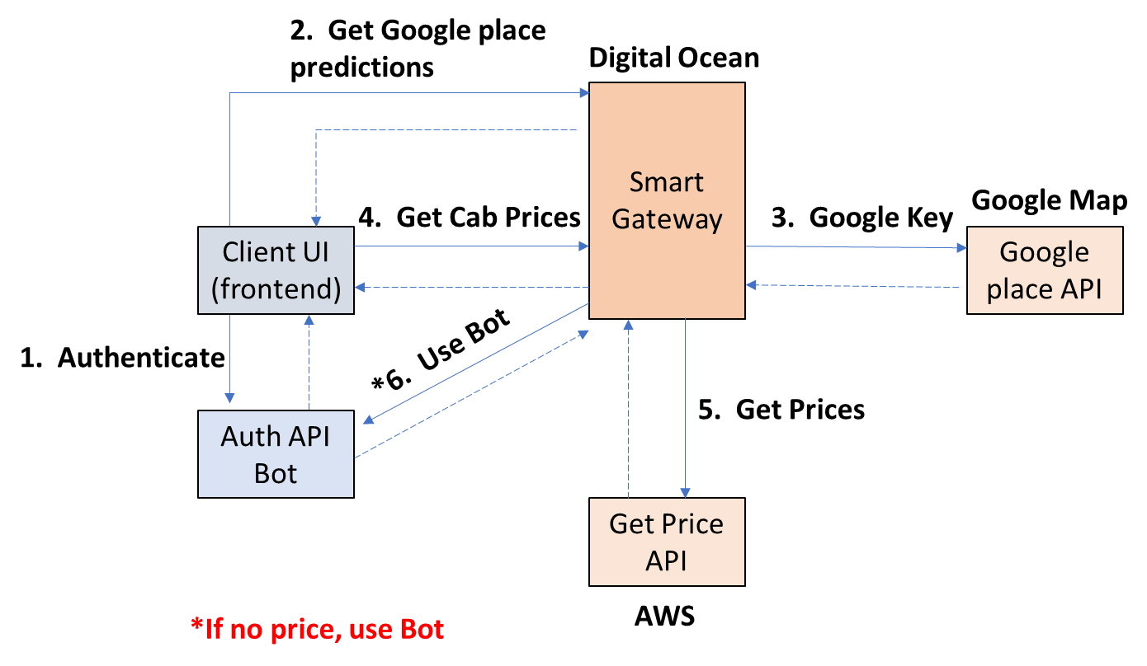

1. **Current Status/Completion**
   1. App already launch in Playstore but Apple (plugins not updated) still having issues.
      1. Backend Admin Control Web written in php language completed – need to enhance some of the control feature and to work seamlessly with the frontend mobile app.
   2. Android App Scrapping Bot (Bot) completed.
      1. Current can only run maximum of 18 Emulators at any one time due to the port limitation by the ADB.
   3. Source codes for the Frontend mobile app, API and backend admin control web are available will be re-writing the code in nativescript.

1.4 Need to enhance the security features of the app. The Googles key authentication need to place in the backend.

1. **Things Need to be Done – In Summary**
   1. The Frontend mobile app needs to work seamlessly with the Backend Admin Control Web, the API, the smart gateway and the Bot to fetch real time prices and timing from the various ridesharing companies in Singapore.
   2. The Gateway will consolidate all the ridesharing companies prices and time and return to the Frontend mobile app to be displayed to the user in a presentable UI as in the current status.
   3. When there is any problem to the API route and/or the Bot route in getting the price and time, the Backend Admin Control Web must be alerted so that maintenance can be assigned to rectify the fault immediately.
   4. In addition to the above development, the followings are things need to be done to the current frontend mobile app, API and backend resource web development to enhance the user’s experience and Admin control:
      1. The frontend app needs various changes to enhance the UI, this will be described in details later.
      2. The Backend Admin Control Web needs several changes to work seamlessly with the frontend mobile app, this will be described in details later.
      3. The API links need to be check to ensure they are working properly and all the various linkages to the Frontend mobile app and Backend Admin Control are working perfectly without problems.
2. **Workflow of a Search Request – Primary Function**
   1. To login, need handphone number and password. Once login, a Blast Advertisement will appear, the User can either close the advertisement or click on it to open the URL to earn points.
   2. Once at the Home page, the home page will be able to track the User current location being set as the pickup location.
   3. User is able to change his current location if different and required.
   4. He will input his desired destination. Using Google map, user will be given choices on the drop down menu and User will select the destination from the drop down menu matching his desired destination.
   5. When both the pick-up and destination are submitted, map showed route from pick-up to destination, user will click on the search button.
   6. The App will use the API and fetch on the price and time based on the pickup and destination address as submitted to all ride sharing companies and providers. On completion, will list down the entire available ride sharing companies’ returns with pricing, time of pick-up and display on the App.
      1. If anyone of the API returns with no data, null data, error data, that particular ridesharing company request/search will be re-routed to the Bot to fetch the price and time. All error must be returned and registered onto the Backend Admin Control Web.
      2. Once all the ridesharing companies’ prices and times are in, it will be display onto the App.
      3. If the Bot also return with error or no data, then this particular ridesharing company will be indicated as “Price Unavailable” on the User App price and time aggregation UI. All error must be returned and registered onto the Backend Admin Control Web.
      4. Currently, for FASTGO, the return is “Not in Operations”. This has to be re-activated when FastGo is back in operations.
   7. User is able to prioritise the listing based on cheapest companies or fastest time companies. The App is able to rank them from the Cheapest to most expensive in ascending order from top to bottom or list them in ascending order from the shortest waiting time to the longest waiting time from top to bottom.
   8. After going through the price comparison list, user is able to select on which ridesharing company that he wants and be brought to the required app to make his booking. With the input pickup and destination addresses automatically send to the required app and the booking page of the app is being shown and opened.
      1. If the selected company’s app is not installed in the User’s mobile phone, he will be alerted that the chosen app is not installed and request him to install the app or choose another company.
      2. If he chooses to install, then he will be brought to that particular app Playstore or Applestore page to download and installed. If he wish to select the rest of the companies, then he will return to the App price and time comparison page.
   9. Once the User click on the ridesharing company link, and choose his ride, this will complete the booking process.
      1. The app/backend must register the details of this booking, the ridesharing company, the price, the pickup location, the destination, time onto the backend web. This will be captured and stored in the Ride Hstory.
      2. On completion, points will be awarded to the User and registered on both the Backend and on his mobile app. Detail of this ride will also be known based on the points awarded.
   10. App remains login unless user logout.
3. **Workflow of Earning Opportunities – Secondary Function**

The Carhailer App will provide the opportunity for the User to earn reward points and accumulate these points into their eWallet. Subsequently, the User can use these points to redeem for awards. Earning opportunities are:

4.0.1 View and click on Blast advertisement

4.0.2 View streaming banner advertisements posted in the app

4.0.3 Click on advertisements in the app

4.0.4 View video advertisements in the app

4.0.5 Using the app to make booking and confirm the ride

4.0.6 Share app with contacts

4.0.7 Share app in social media

4.0.8 When contacts download and install the app

* + 1. Participate and complete posted survey
  1. User will select the Earning Opportunities from the side drop down menu.
  2. From the list of advertisement, User will click on any one to view the advertisement and earn points. Points are set in the Backend Admin Control Web.
  3. The time required to spend on the individual advertisement will be set at the Backend Control. If the User did not fulfil the time required on the advertisement, points will not be rewarded and the User will be alert that he needs to spend XX time more in order to earn the reward points.
  4. Not to allow the User from abusing and continue to earn reward points, there must be a counter limiting the number of repeated views that the User can earn points from any of the advertisements. Once view or click limit is reached, the User can still view or watch the advertisement but points will not be awarded. All these must be able to set from the Backend.
  5. The viewed advertisements and points earned will be captured and updated on the User mobile app and also at the Backend.
  6. All the advertisements posting are controllable and able to be posted/deleted from the backend. When updated, the frontend mobile app will be updated too.
  7. Different points earned for viewing video, sharing, engagement, etc will be controllable and editable from the backend.
  8. All points earned by the User will be in his registered and captured in the User mobile eWallet and also at the Backend. User is able to redeem points to vouchers or exchange of items depends as listed in the Redemption page in the App.

1. **Various Pages in the Current Frontend Mobile App**

5.1 Sign Up page

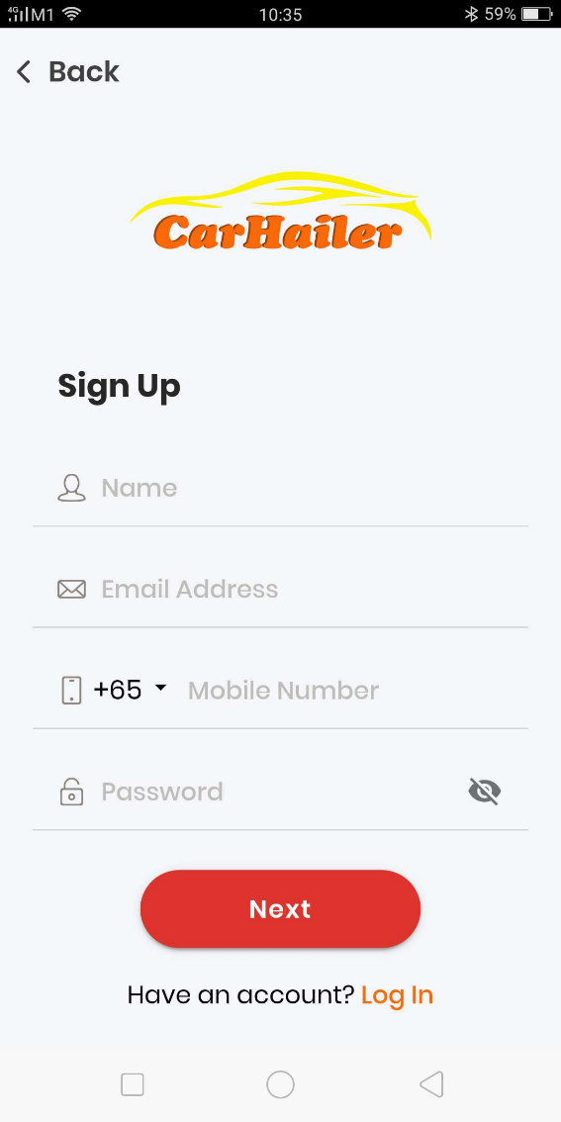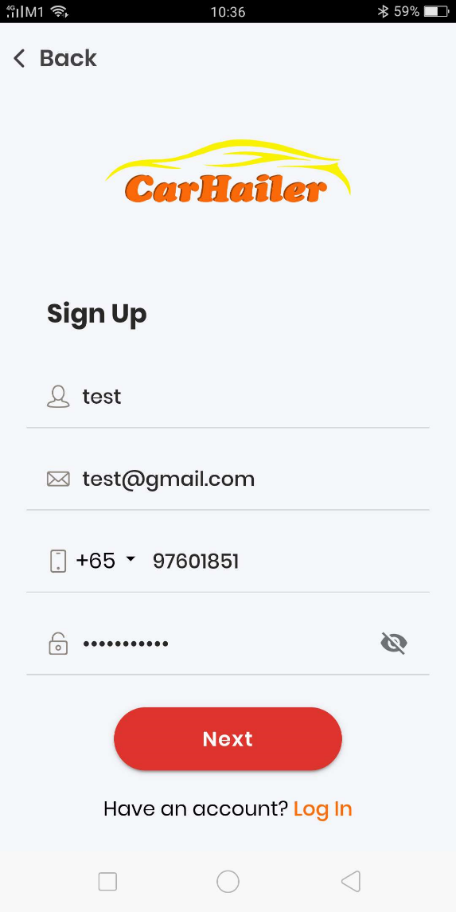

Upon submission of sign up, the User will need to key in the OTP that send to the submitted mobile number.

In addition, User will need to go to his email to verify his email.

When these are done, User will be brought to the Login page to login again.

5.2 Login page

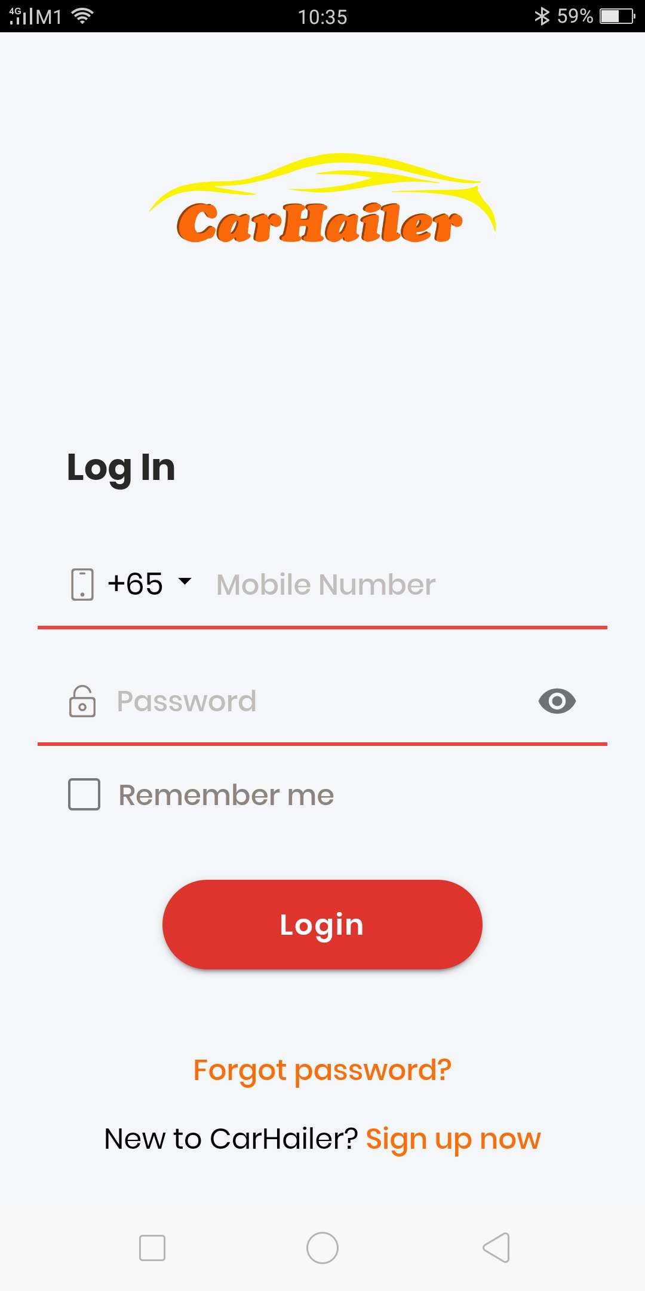

When the User press on the “eye” icon, he will be able to see the password that he has typed.

User can also reset his password if he has forgotten his password.

Able to use handphone and password.

Able to link to social media accounts to login. Facebook, Instagram, Google, etc… need to tie up with at least one or more accounts.

Able to access contacts from user accounts so that user is able to share app with his contacts. Earn points when contacts download and install our app.

5.3 Sign Up Verification

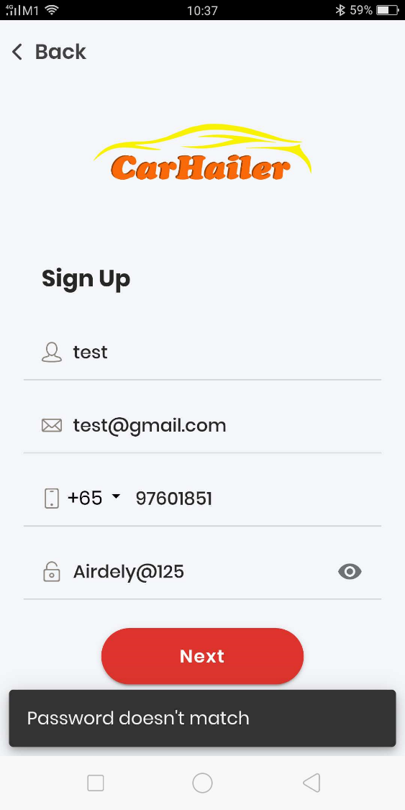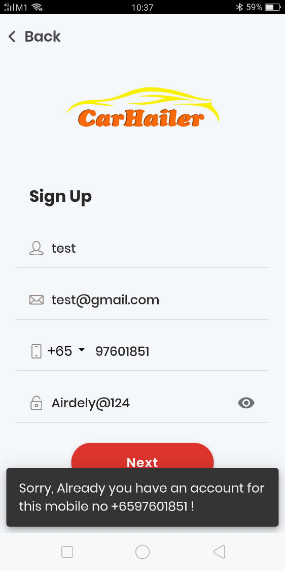

Please note the above, because of display, only ONE password input field was shown, it has actually TWO. If the password doesn’t match, the User will be notified.

In addition, if the User already has an account, either the email or mobile number is being used, he will also be notified that there is an existing account using the email or mobile number or both.

5.4 Login page

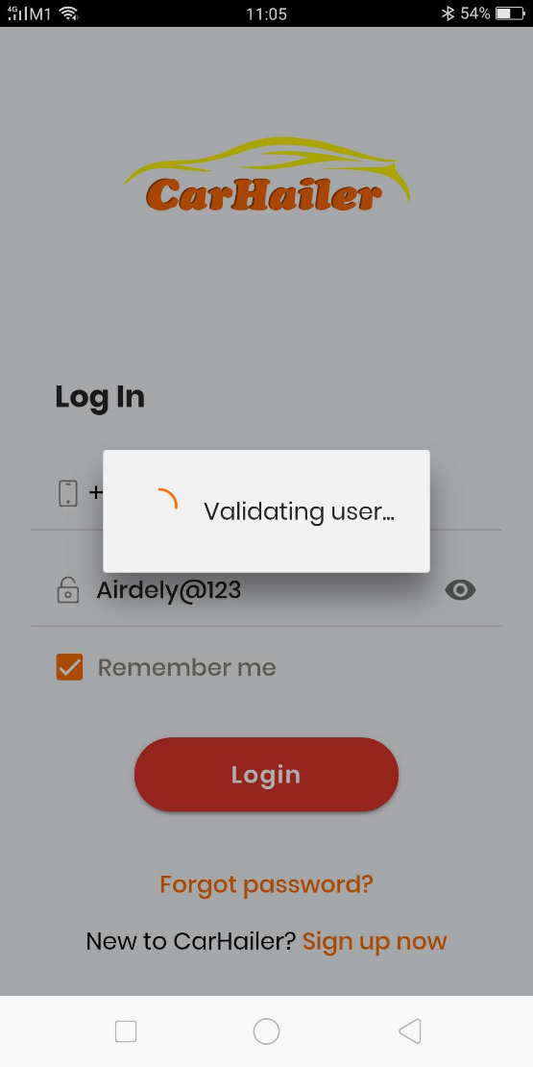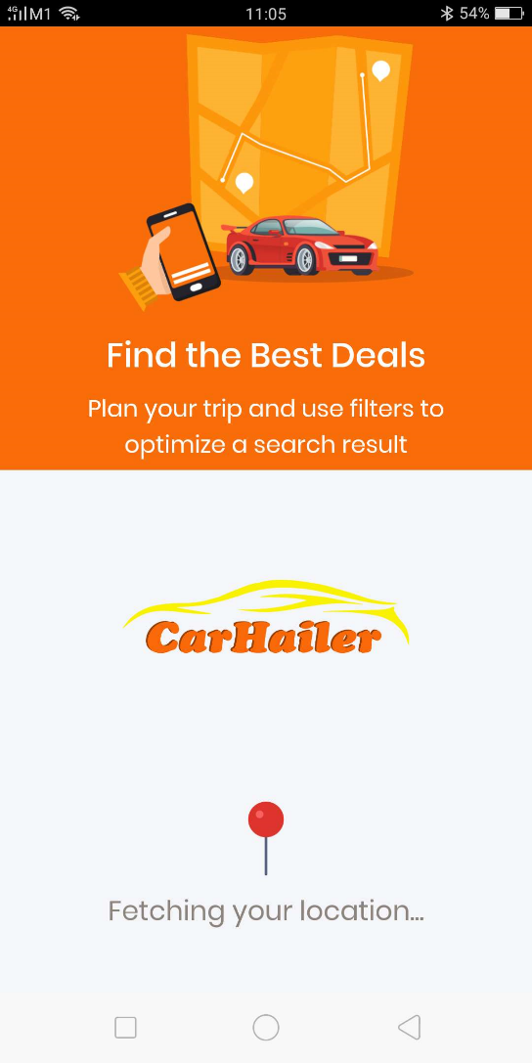

Once Login is pressed, the Backend will verify the User credentials. If passed, then the App will move on to the Landing page.

5.5 Blast Advertisement page



While the Landing page is loading and also getting the geo location of the user current position, the Blast advertisement will be flashed on the App.

The Blast advertisement is static, it contain a poster, a description and also a clickable link to re-direct the User to the URL of the advertiser or to the downloading Play store or Apple store page.

As mentioned, the App remains signed in unless the User Log out. Hence when the User closes the App and re-open it again, the Blast Advertisement will also appear before the Home page of the App is being loaded.

The Blast advertisement is set and control at the Backend. It is one page static poster advertisement. There are numerous Blast advertisements that can be set. The User will see only one at a time. When he next turn on the App, he will see a different one, and so on. Then the Blast advertisement will recycle again.

5.6 The Home page and Input Location page

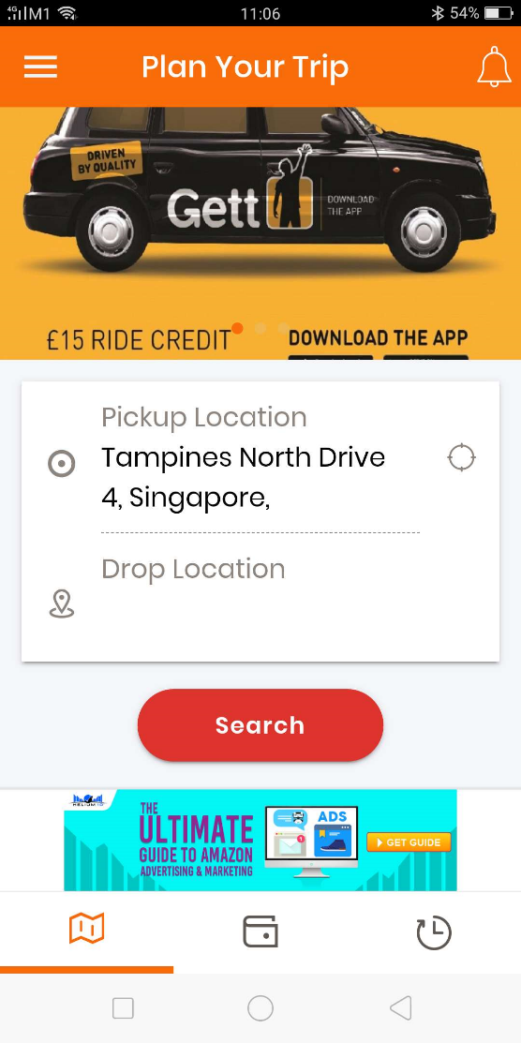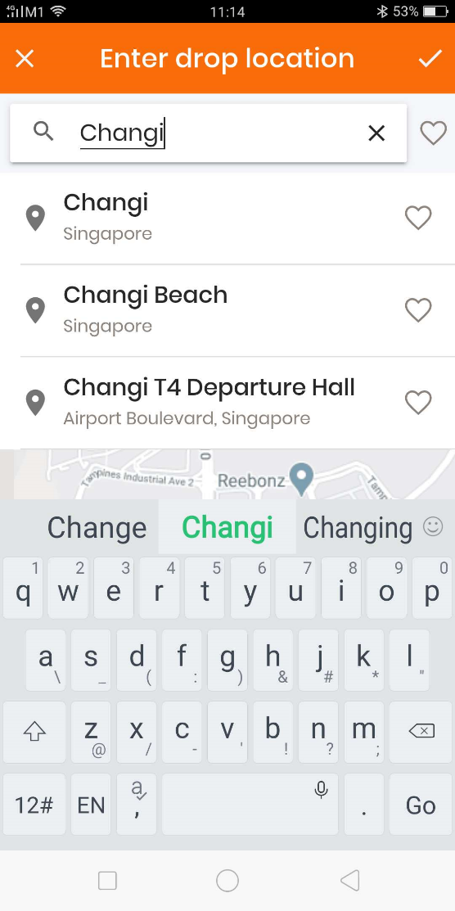

When the User close the Blast advertisement or return back from the Blast Advertisement. He will landed up on the Home page of the App.

By now his current geo location will have already determined and displayed on the Pickup Location field. He can choose to change it if need to then he will be brought to the next page to key in his address and select from a list of drop down menu base on Google map setting.

He can also insert his favourite address if he has saved previously.

When click on the Drop Location or should change to “Destination”, then he will be brought to the next page to key in the address and choose from a list of drop down menu same as previous or to insert his saved favourite location.

In addition, he can also add new address to his favourite list too.

5.7 Input Location page back to Home page

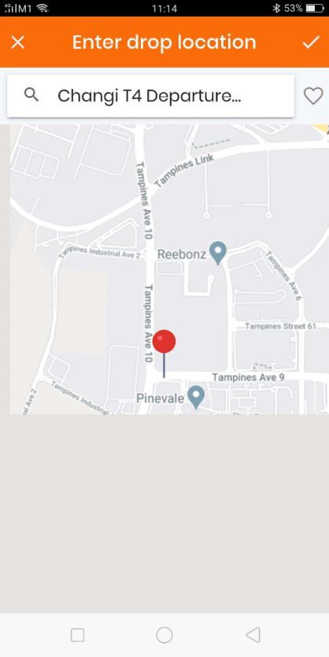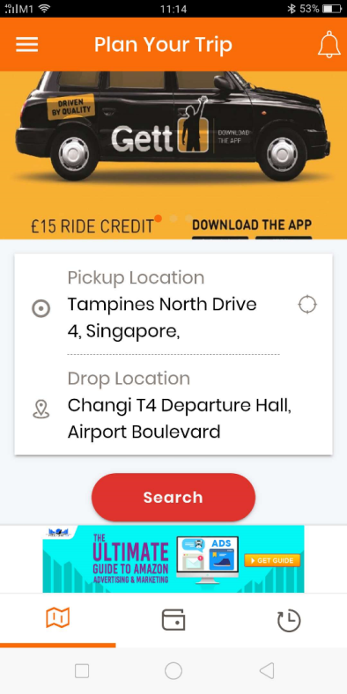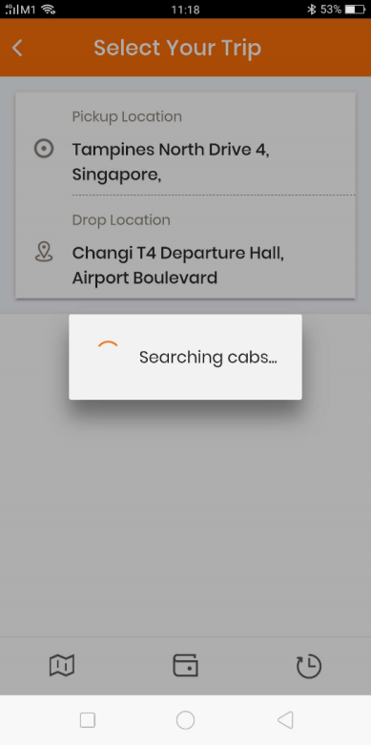

When the User has input his destination, it will be shown on the Google map. The User can do fine adjustment by moving the location pin on the map is need to.

Once complete, check on the Tick icon above and he wll be brought back to the Home page so that he can depress the “Search” button.

Once the Search button is depressed, it will show “Searching for Cabs”.

This is when the pickup and destination address will be sent to the ridesharing companies to obtain the various prices and timings. First using the API method, and if there is problem, will use the Bot method.

If the waiting time to get the prices is too long, can update the User whenever the prices and time of the various companies are in, example as follows:

Searching for Cabs 🡺Fetching Grab prices 🡪 Fetching Gojek prices 🡪Fetching Comfort Delgro prices and so on.

The above may not be required to go inaccordance to the data obtained, the changes in wording just to keep the User occupied that the App is indeed running correctly.

5.8 Price Comparison page – Selection page

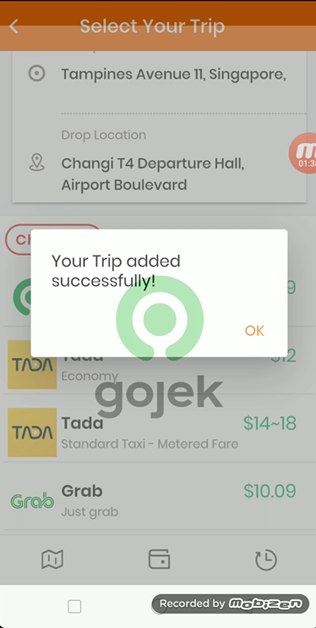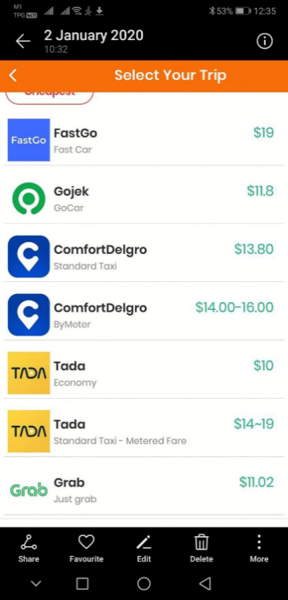

When all the ridesharing companies prices and times are consolidated are fetched successfully. The data will be displayed as shown above.

The User can rearrange the display by pressing “Cheapest” button, the various display will be re-arranged with the Cheapest companies being above and highlighted.

When the User choose the company, the time, the Pickup and Destination address, the company, the price will be registered and stored in the Backend and also the Trip History in the User App.

The App will open the ridesharing company’s app for the User so that he can input the pickup and destination address on the ridesharing company app and proceed his booking from there.

The above is the User selecting the Gojek company and the Carhailer app will take the User to the Gojek app.

If the User has not installed the Gojek’s app, then the Carhailer app will alert the User with a popup that the app is not installed and he can either installed it or to select another company.

5.9 Reselection – Price Comparison page – Selection page

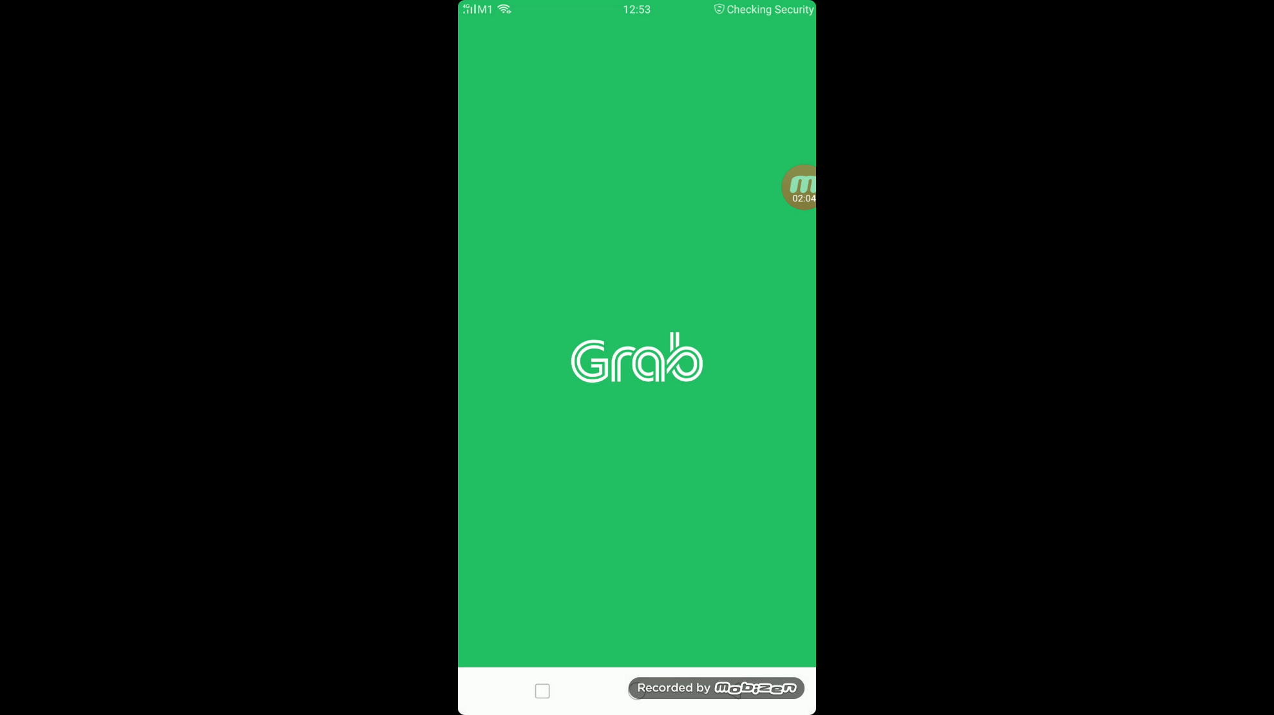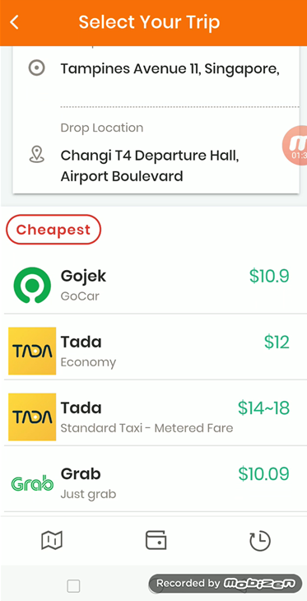

If for whatever reason, the User decided not to use Gojek after opening the app, he can just close it and return back to Carhailer app and do another selection.

5.10 Opening Ridesharing Company App After Selection

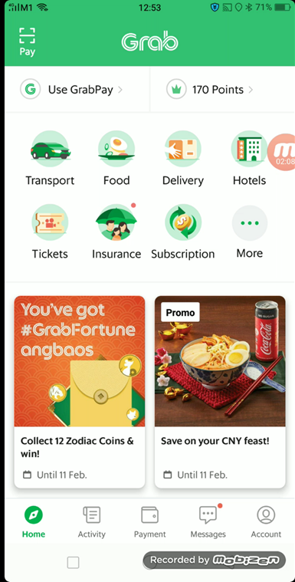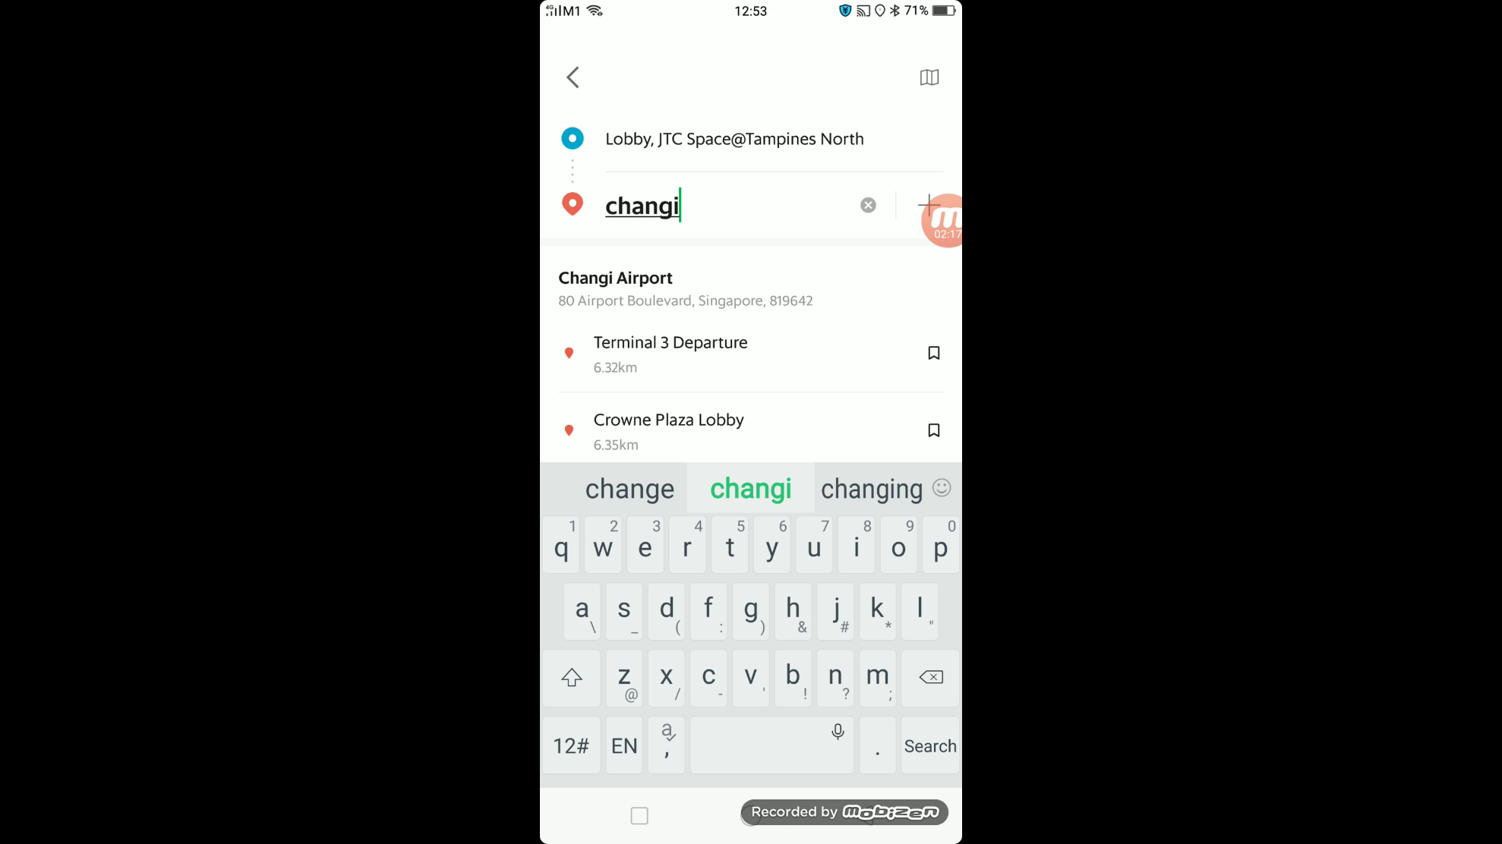

Current problem:

As can be seen from the above snapshot, after selecting the ridesharing company, the User is required to re-key in his destination again,

It will be good that the destination can be automatically planted base on the input in the Carhailer App.

**The above pages listed down the steps and navigation through the pages in searching for the correct ridesharing companies.**

5.11 The Side Menu

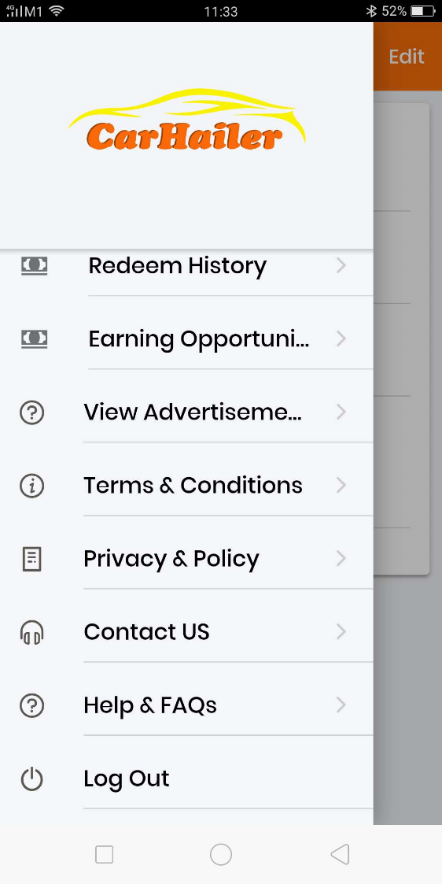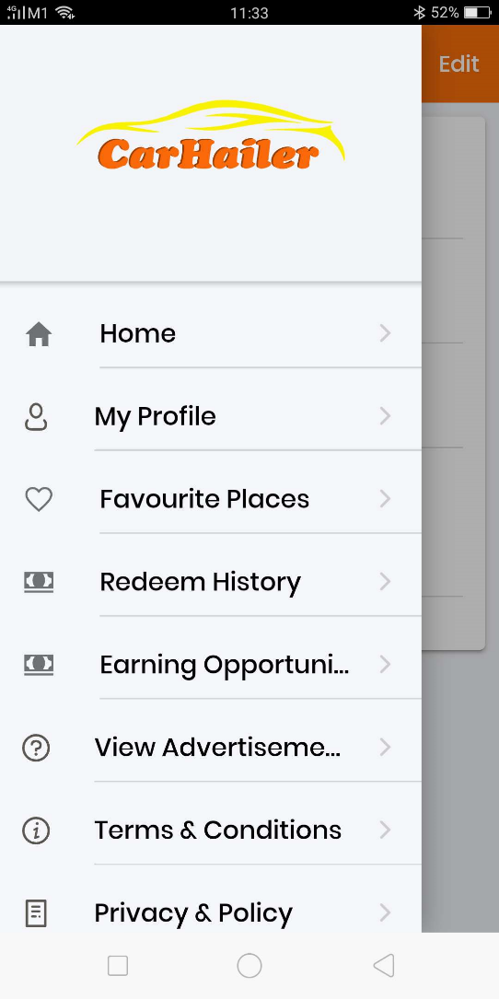

The above shows the various side menu of the Carhailer App.

Below the Carhailer logo, there should be the User name, mobile number and email displayed.

5.12 My Profile page

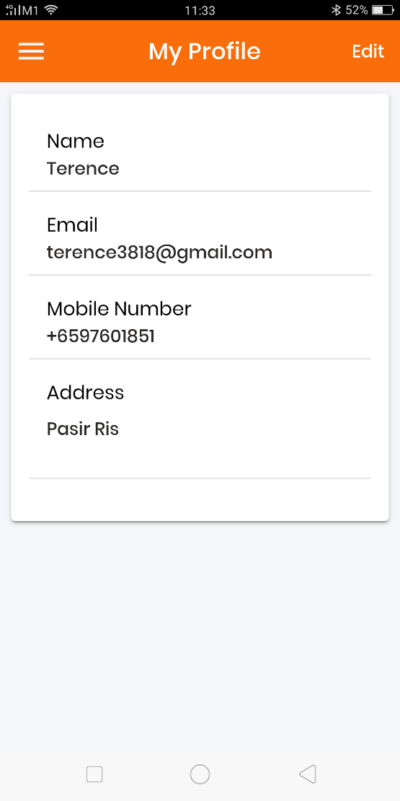

The above shows the My Profile of the User.

His registered name, email, mobile number.

He will need to edit and insert his address in order to redeem for rewards.

If the address is not given and updated, when he redeems his rewards or exchange rewards using his points. He will be notified that he will need to do this.

5.13 Favourite Places page

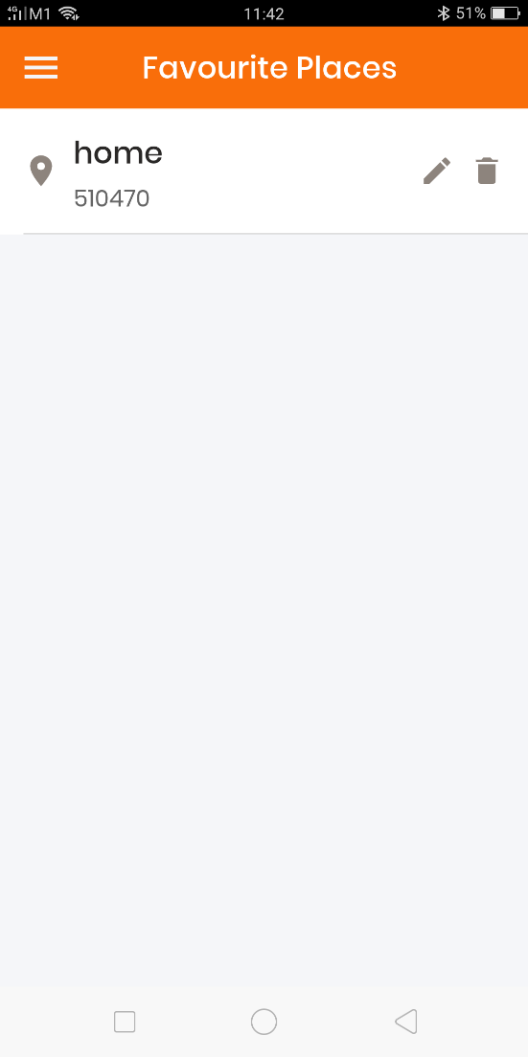

User is able to add his favourite places either in the Search field as mentioned before.

Alternatively, he can also open this page to insert his favourite pages.

On this page, he can also edit or delete his favourite places.

Favourite places can be Home, Office, Work, Eating Places, Interest, Shopping, etc which the User can set and add himself.

5.14 Advertisement page

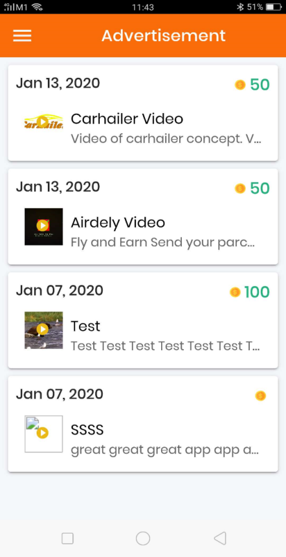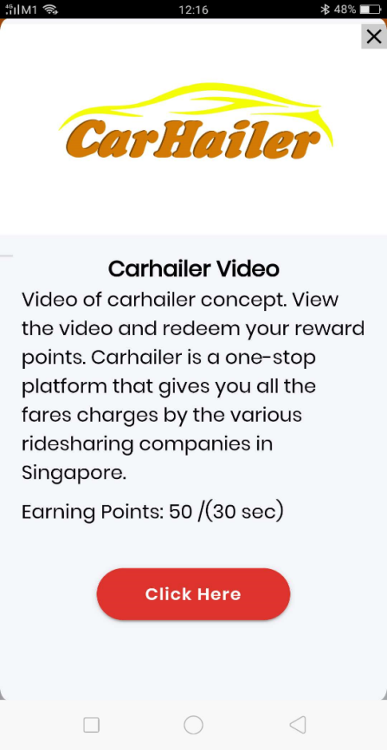

On this page, this is where the User will be able to earn reward points by clicking and viewing the video advertisement posted in this page.

The points that can be earned is on the banner.

A snapshot of the video and description of the video or company can be inserted.

The posting of the video, description, view limit and points earn are all control and administered from the Backend.

Missing item – The view limit is not provided in this App, hence will need to insert the view limit onto it. The Backend will be able to set the number of views that the User can watch this advertisement and earn points. Within the view limit, the points will be awarded.

When the view limit is reached, the User can still watch the video but no more points will be awarded.

In addition, the length of the video must be shown here too.

Please see next page on a good and desired layout of a video advertising page.



This is the link to the URL as provided by the advertiser. When click, will link to the URL as set by the Backend Web.

This Space here is to insert the advertisement description.

The contents are control and insert from the Backend Web

This Space if to insert the Advertiser Details:

Compay name

Company logo

Contact details

The above contents are control and insert from the Backend Web

Points

Video playing screen, please note there is no fast forward, replay, stop, pause in the viewing screen.

View timer showing the remaining time that the video will end.

Please note that there is no Close button available. Once play the video will continue and unstoppable. User can press the back button, once press, the popup will alert that if he exits, there will be no points awarded.

The STOP button will appear when the video is completed.

The Desired Layout of the Video Advertisement Page on the App

User can mute the sound if he wish to. This is the only control available to the video.

5.15 Earning Opportunities page

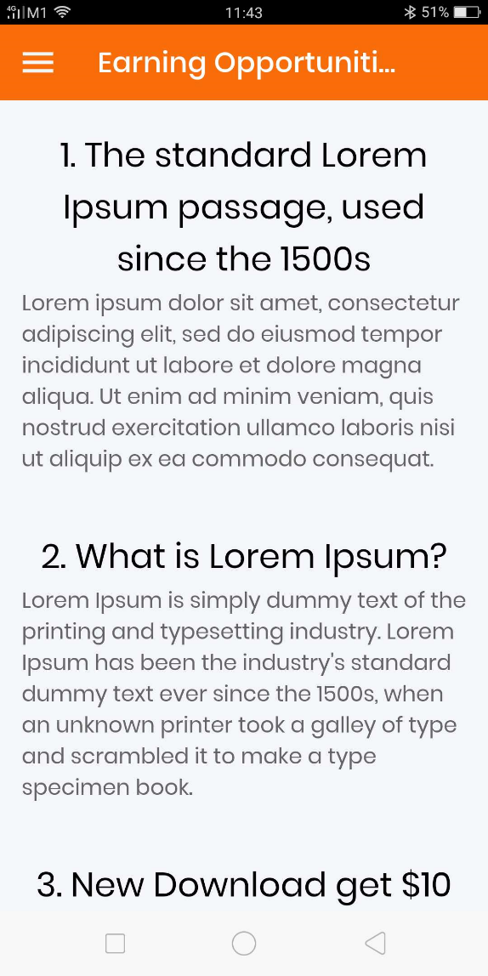

This page is actually an explanation page. This page will explain how the User can watch and click on advertisement to earn reward points and how to redeem.

The list of text are inserted at the Backend web and displayed over here. This can be updated any time and the frontend app will be updated accordingly.

5.16 Redemption History page

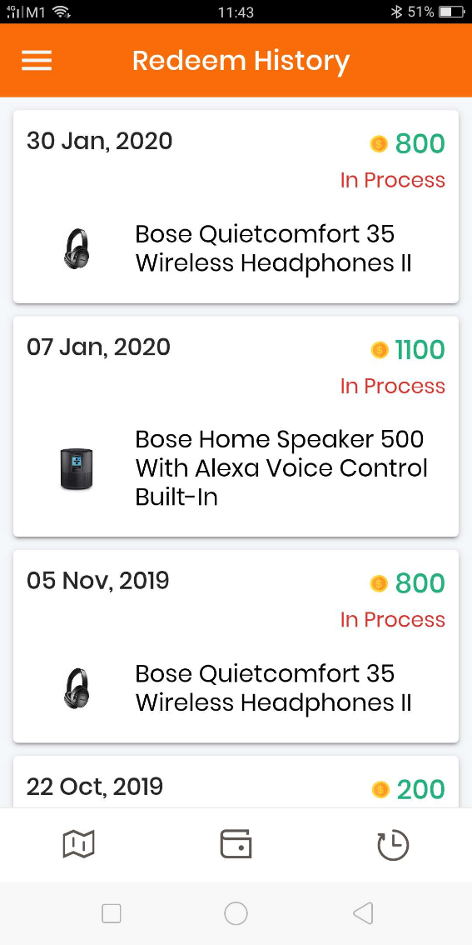

This page shows the redemption history of the User when he exchanged his points to redeem rewards.

The updates are control from the Backend.

When the item is processing for delivery, it will be shown as “In Process”.

When the item is delivered, it will be shown as “Delivered” or “Received”.

The amount of points spent on this redemption is also being shown.

5.17 Redemption page

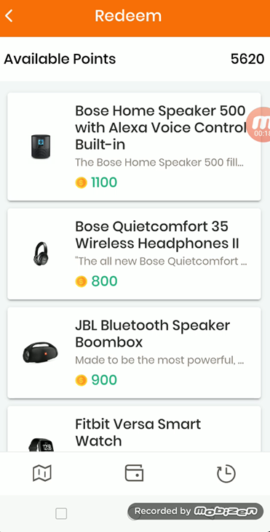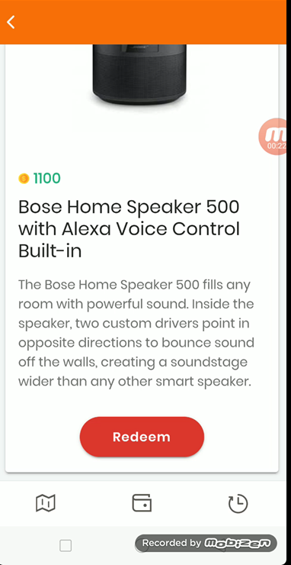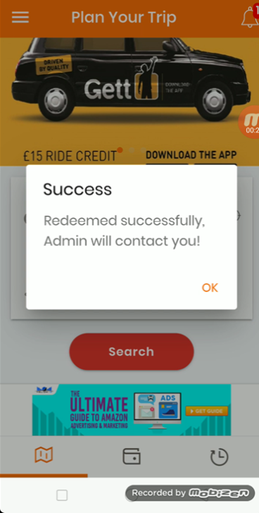

The above show the Redemption page.

List of redeemable items are listed and the User can browse through them to select the items that he wants to exchange his points.  
  
His available points are shown.

Once he click on any of the item, the item will be display singly for him to view the picture, description.

He can choose to go back to the Redemption page or proceed to press the “Redeem” button. Then he will be infomed that his redemption is successful and Carhailer Admin will contact him.

One he submit, the Backend will be updated and the Admin will arrange the redemption.

Currently missing:  
A Redemption Cart, that all the items can be posted there and the User can de-select or cancel or delete any items.

5.18 T&C, Privacy Policy, Contact Us and FAQ pages

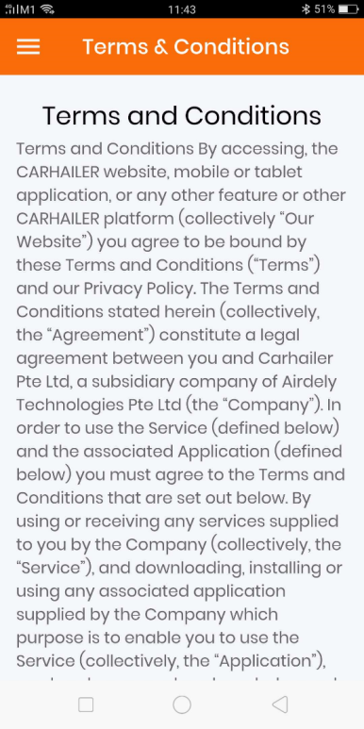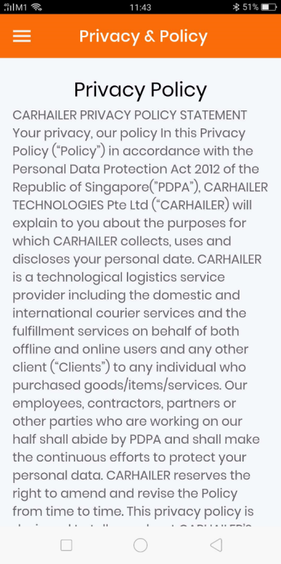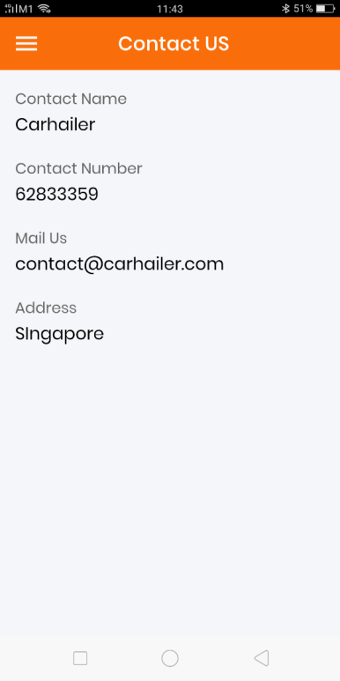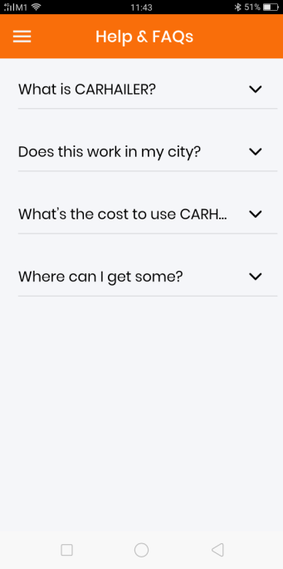

The above show the various pages on the T&C, Privacy Policy, Contact Us and FAQ.

The content of these pages are administered from the Backend. Once update from the Backend, the Frontend App will be updated accordingly.

Missing: A Search function within this page that the User can search for specific keywords and brought to the relevant paragraph.

5.19 eWallet and Rewards pages

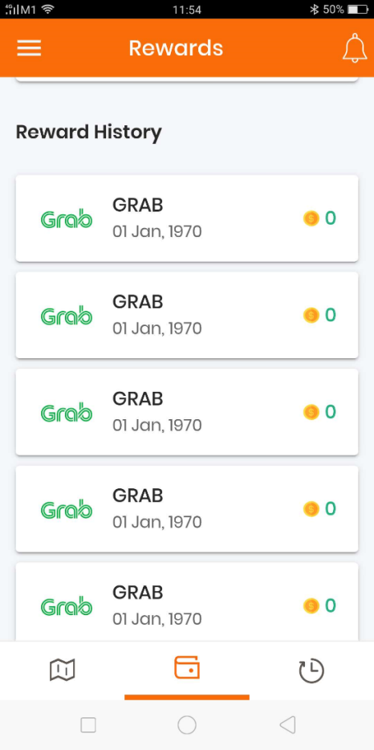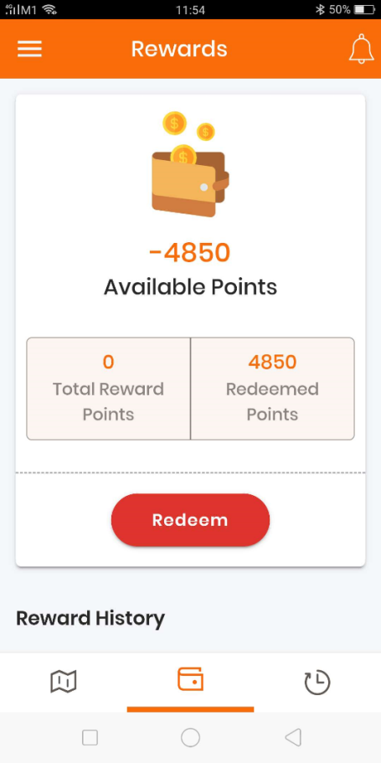

The page shows the reward points available for the User or the points that he has earned on the various earning opportunities that he has completed.

The points will be calculated and updated accordingly when there is earning or redemption being made.

Wallet will accumulate points for users when he works on the earning opportunities.

Wallet will show his transactions in details.

Wallet will show his balance points and total withdrawal points.

Wallet will show what being transacted.

Wallet will show user total saving achieved till date. Calculated based on the most expensive ride versus the lower price rides that he has chosen by using our app.

5.20 Notification page

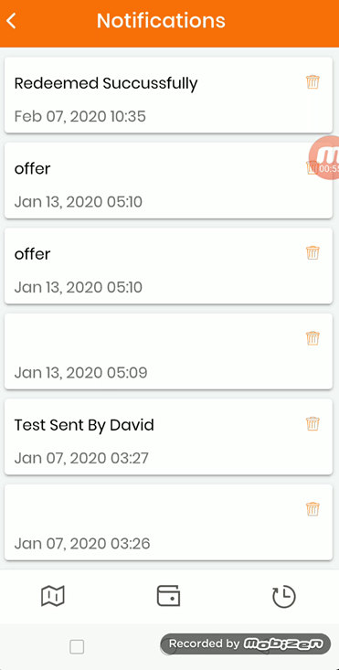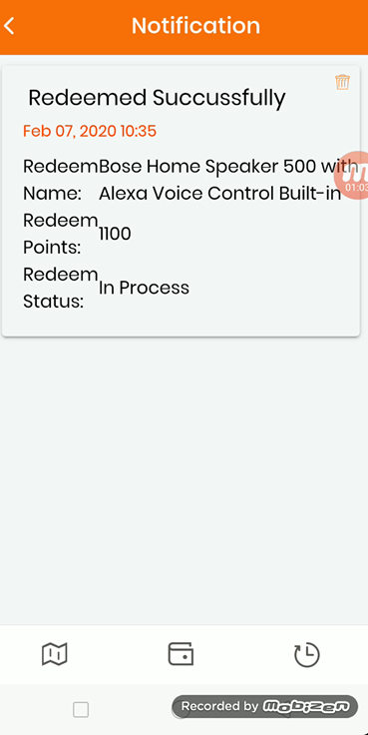

The above shows the Notification page.

Notification can be a push notification, blast notification or personal notification being sent out by the Carhailer Admin from the Backend.

When press on any of the notification, it will be expanded.

User can also delete unwanted notification from his App if need to.

5.21 Trip History page

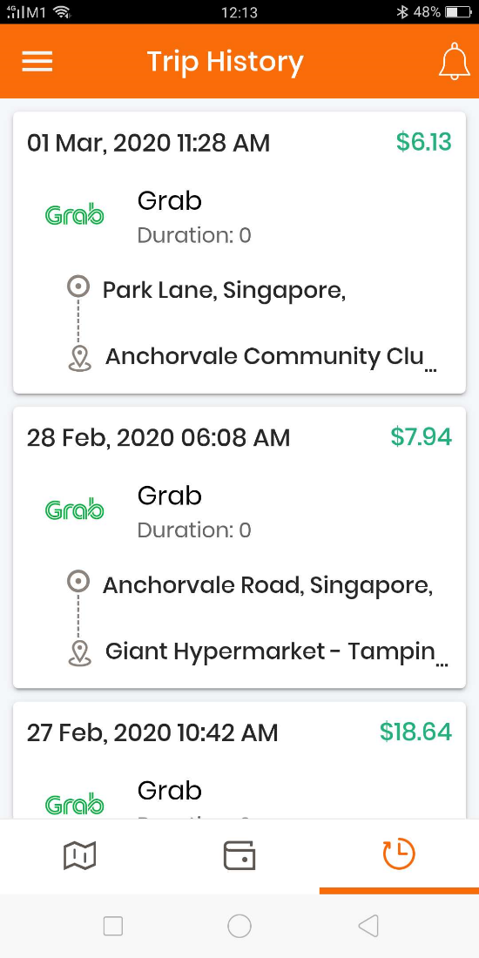

This page shows all the ride bookings that the User has made through the App.

1. **Backend Admin Control Web Requirements**
   * 1. Backend will capture all data from users, his particulars, ride history, login habits, travel details, behavior in using the app.
     2. All details will be captured and stored and display from the user.
     3. Control of advertisement posting and display. Completed but need to make adjustment.
     4. Control of video advertisement and display. Completed but need to make adjustment.
     5. Post surveys for participation. Yet to develop.
     6. Surveys when completed by user will be able to see from backend and download and archive. Survey pertaining to user profile and particulars will be updated and stored in user account. Yet to develop.
     7. Push notifications and advertisements to users or selected users. Completed but need to make adjustment.
     8. Control promotions and discounts by having public or private promotion code. Yet to develop.
     9. Able to control individual country settings for ride sharing companies and providers. Using geo location to capture User location so that the App will be smart to list only those ridesharing companies operating in that area. Ensure app has the global reach. Yet to develop.
     10. Ensure that NO ride sharing companies or providers able to block our app from accessing their API. Hence may need to develop a hopping/rotational IPs to link up on the API. Yet to develop.
     11. Able to link with ride sharing companies and providers for discount and promotions. Yet to develop.
     12. Advertisements will be able to be controlled to be displayed in different locations, countries, time and specific users or all users. Completed but need to make adjustment.
     13. Able to add and delete ride sharing companies and providers and able to set for different countries entry. Yet to develop.
     14. Able to filter user individually from all data captured.
     15. Able to link directly to user accounts with individual ride sharing companies apps. Yet to develop.
     16. Maintain company revenue and payout. Yet to develop.
     17. Able to set clicking and viewing limit per user on advertisements. Completed but need to make adjustment.
     18. UIs and designs are controllable and editable. Completed but need to make adjustment.
     19. Able to see users points earning and control, edit amount if required. Completed but need to make adjustment. Need to be able to make changes to the points by the Super Admin if need to. Completed but need adjustment.
     20. Able to post surveys for user to participate and earn points. Yet to develop.
     21. Able to track number of uses per user, need to segregate and filter, day, week, month and time. Yet to develop.
     22. Backend will support different users login account giving special rights to view different log. Example, account will be able to see account pages only. Advertisement Sales will be able to see and configure advertisement pages.
     23. Able to set points earn by individual video and survey. Different video and survey will be allocated different points as set by backend. Completed but need to make adjustment.
     24. Able to set description on the video and survey. Able to display the estimated time of the video and survey. Completed but need to make adjustment.
     25. Able to issue vouchers or discount QR code if given by vendors. Yet to develop.

Please see the following pages on the various completed setup of the Backend Admin Control Web and their description.

**The followings are the various pages for the Carhailer app backend and its function.**

**6.1 This is the Backend Admin Control Web login page**

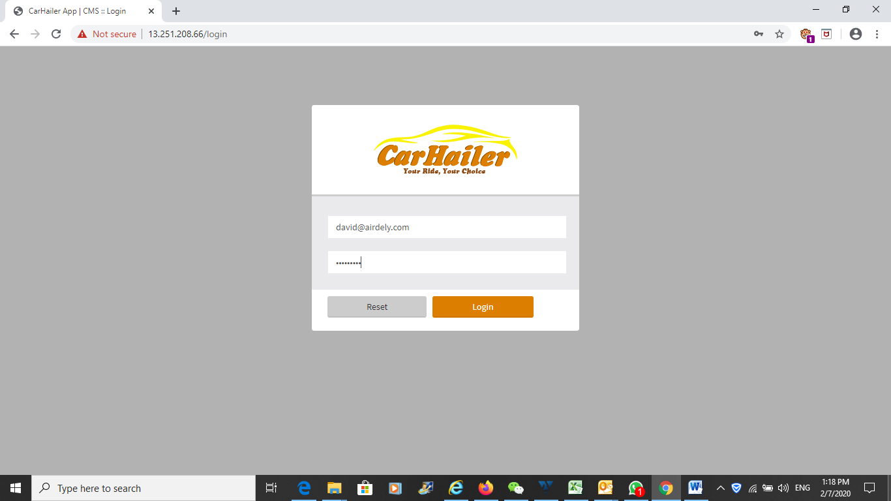

The above is the login page. Using email ID and password to log in.

http://18.140.1.25/car-app/cms/settings

Use this Super Admin credential:

[david@airdely.com](mailto:david@airdely.com)

Password: David@118

* 1. **The User Management page**

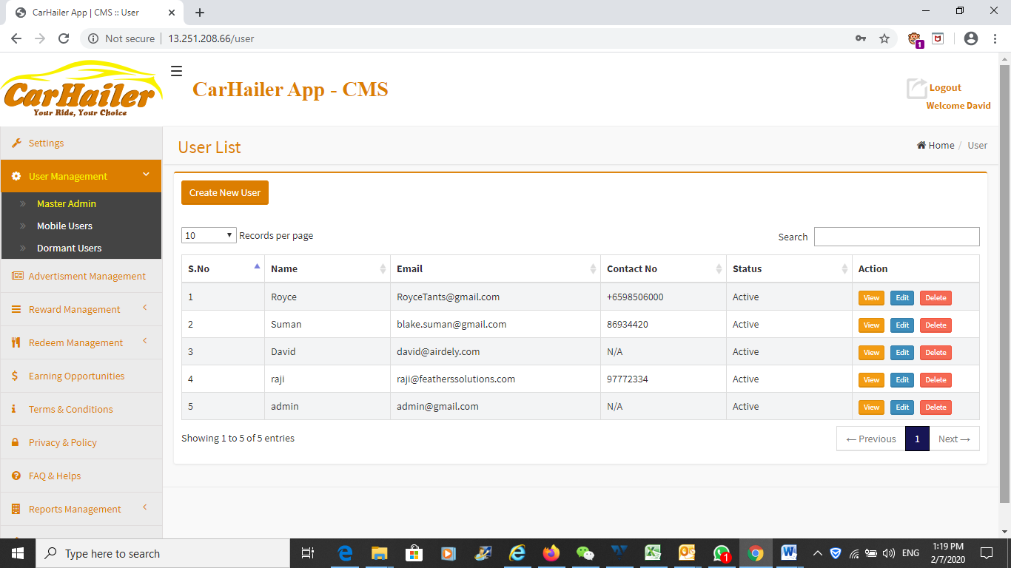

There is no landing page or dashboard in the Carhailer backend.

The above is the User Management page which will control the Admin user and also all the rest of the normal mobile app users.

Will be good to have a landing page/dashboard to provide a summary on the various functions in a glance.

Please see below example:

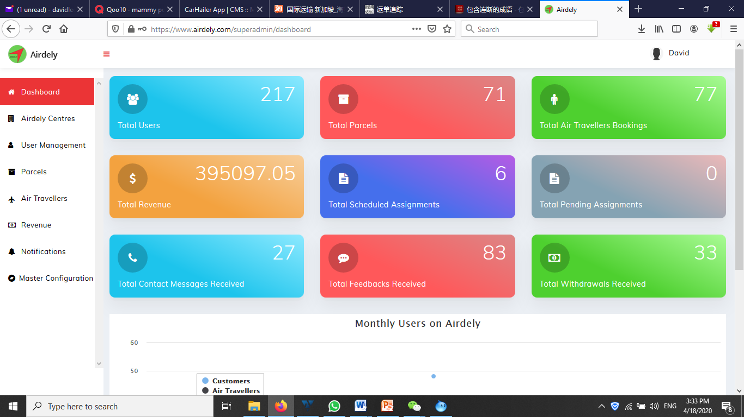

* 1. **The Setting page**

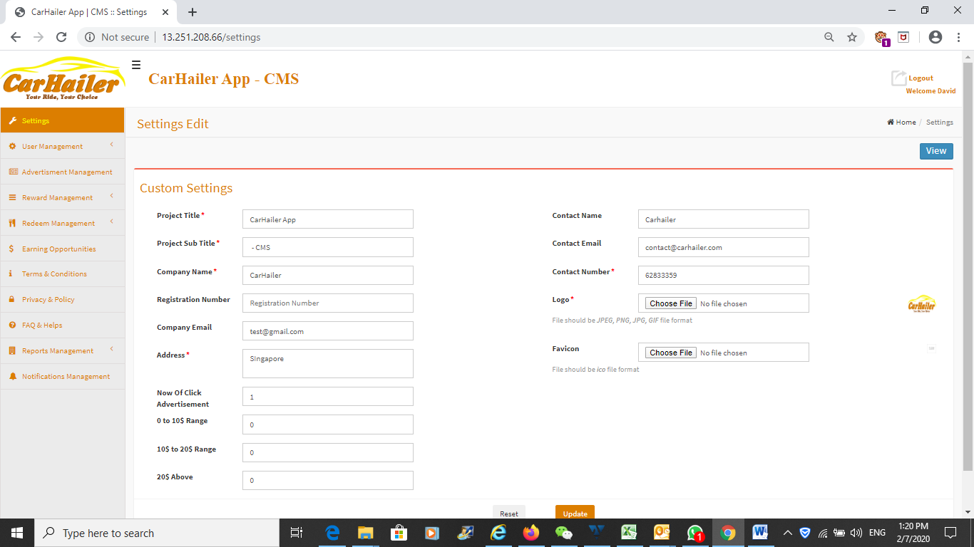

The above is the setting page. This can add or edit the various functions as stated in it. However, this is no good, there should be a Master Configuration page so that the various control, edit and updates should be there.

Namely:

1. Contact Us
2. About Us
3. Terms and Conditions
4. Privacy Policy Statements
5. FAQs
6. Feedback
7. Control and edit of the mobile app appearance, icons, UI

This page should be rename as the Master Configuration page with the various setting occupying individual page setting on a Top Menu.

In addition, for all pages, the Super Admin can edit, delete any of the item information. This capability is only given to the Super Admin.

* 1. **The User Management page**

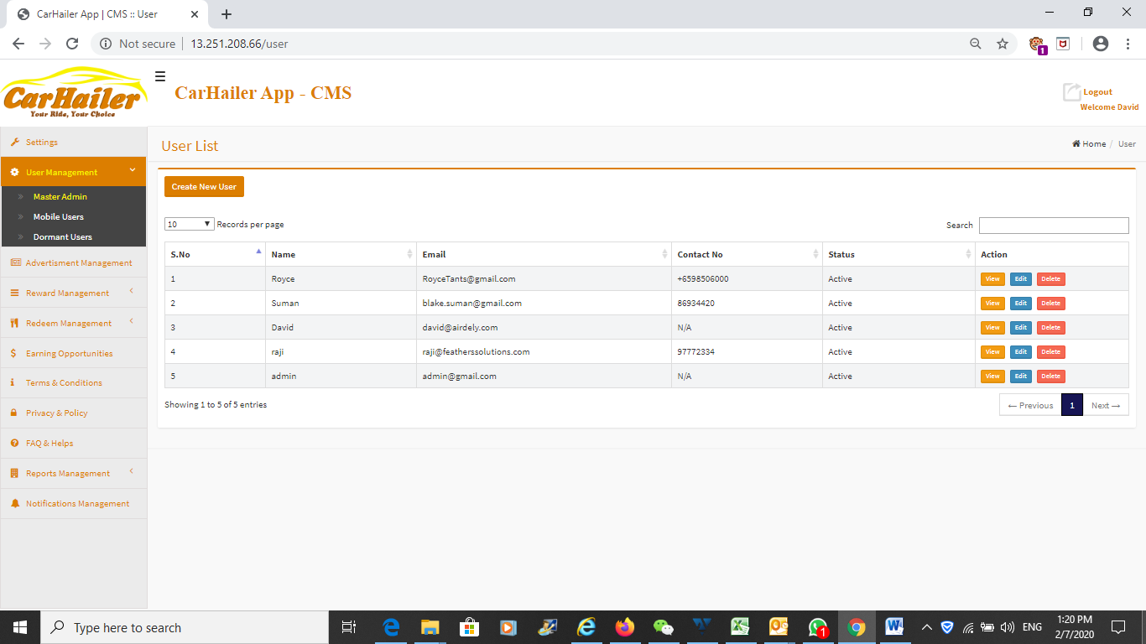

Above is the User Management page. The display is limited. Should have more information for the User, examples:

1. User country – either based on his Country of registeration or from his mobile number country code
2. Registration date
3. Last login date and time
4. Points earned
5. Points redeemed
6. Points balance
7. Address

Please note that the password of the user to login into the account can be seen under edit. If need to, the Admin is able to reset the password for the User.

* 1. **The User Management page – The Admin User Assignment page**

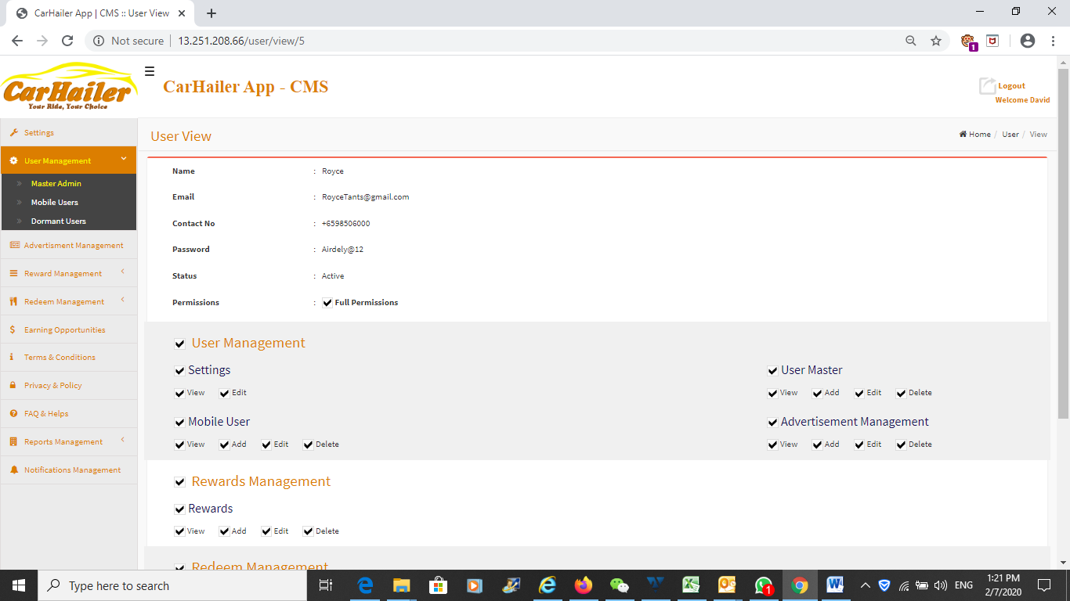

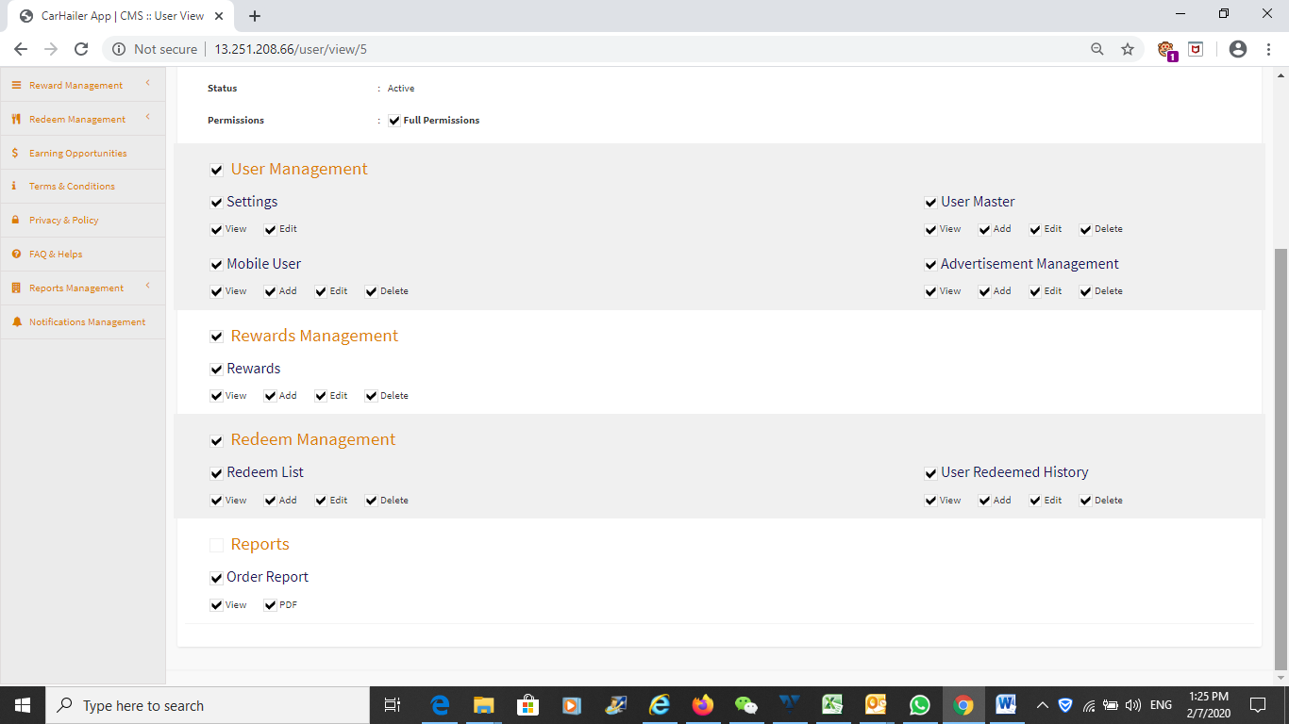

Above is the view Admin role designation and assignment page. Can view the Admin with different role responsibility.

Only Super Admin can add another Super Admin. No Admin is able to assign someone with level higher than him but can be lower. This may not have been set yet.

* 1. **The User Management page – The Normal Mobile Users**

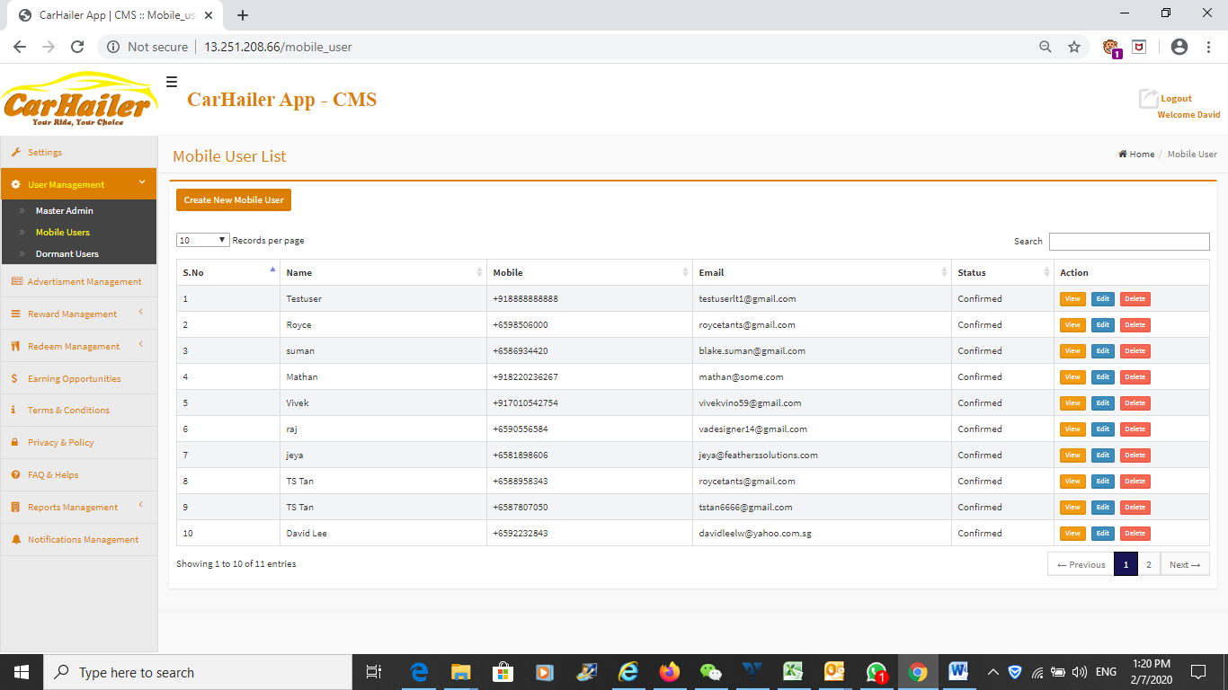

Above is the User Management page. The display is limited. Should have more information, details and particulars for the User as described in previous page.

Please note that the Delete button should only be made available to the Super Admin.

If the Admin login, he will only be able to do the normal editing functions but unable to delete the Users.

One very important feature and must be activated is the Delete function. When the Super Admin delete a User, his information will all be deleted from database. Hence this User will be able to re-use his email, handphone number to re-register again. This was done but somehow it is not working.

Will need to check.

* 1. **The User Management page – View Function**

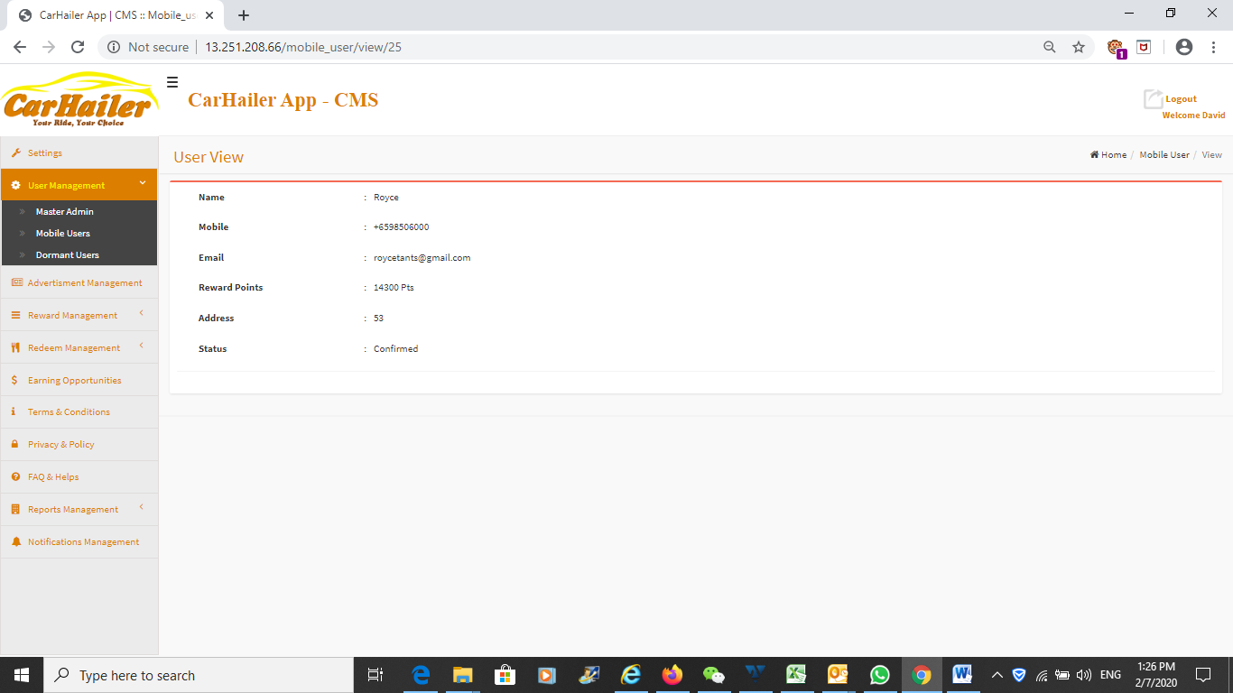

User view. Should have more information on this page.

Too little information.

When started, will post survey for the User to complete, and all information filled in the survey form will be captured over here.

* 1. **The User Management page – Add User Function**

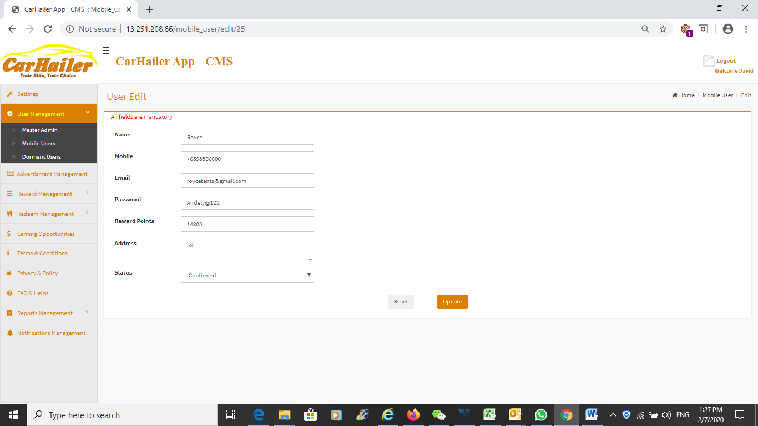

Add User functions.

User can be added manually by the Admin is required. Can also edit too.

* 1. **The User Management page – Dormant User page**

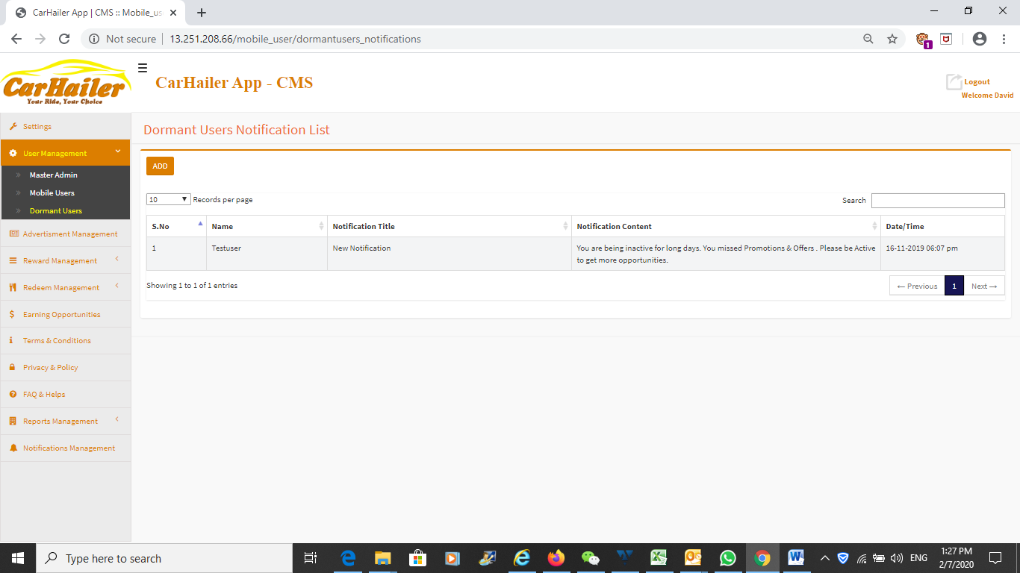

When a User is dormant for more than 2 months without logging in, then his profile will be highlighted in this page and Admin will be able to check with User personally for feedback and to promote usage.

This is to enhance User experience with the company.

* 1. **Advertisement Management page**

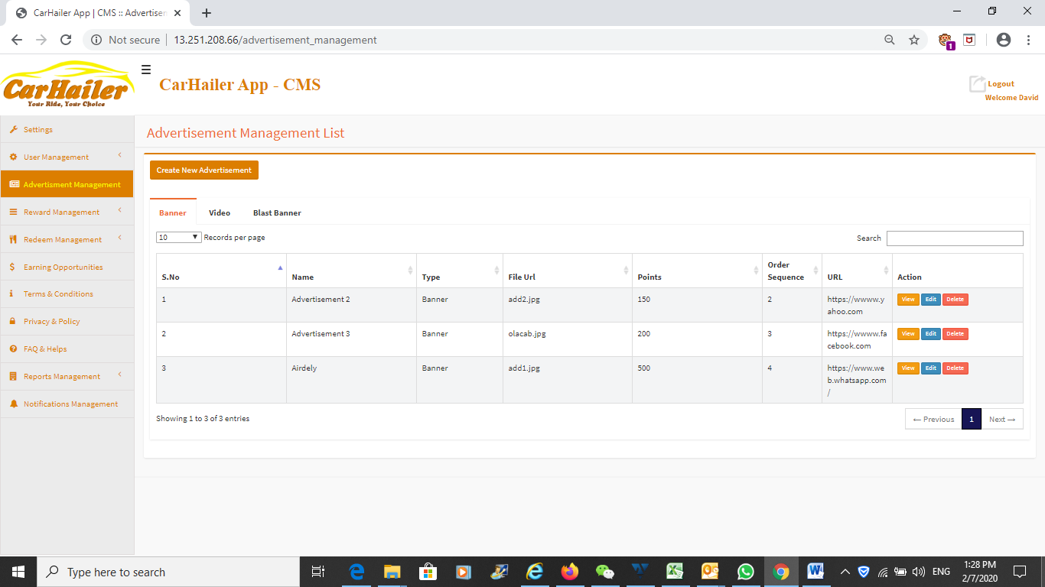

Above is the Advertisements management page.

In this management, the Admin is able to add different type of advertisements to the frontend app, namely, Blast advertisements, Banner advertisement and Video Advertisement.

The Admin is able to update, edit, add, and delete the various advertisements when required.

This page lacks one function, which is supposed to have but did not develop. To add in a Survey module where the frontend app user is able to complete any survey posted and earn points. Same goes for the Frontend mobile app, the survey menu is not built.

When the advertisement is no longer valid, it can be deleted using this page.

* 1. **Advertisement Management page – View Advertisement Setting**

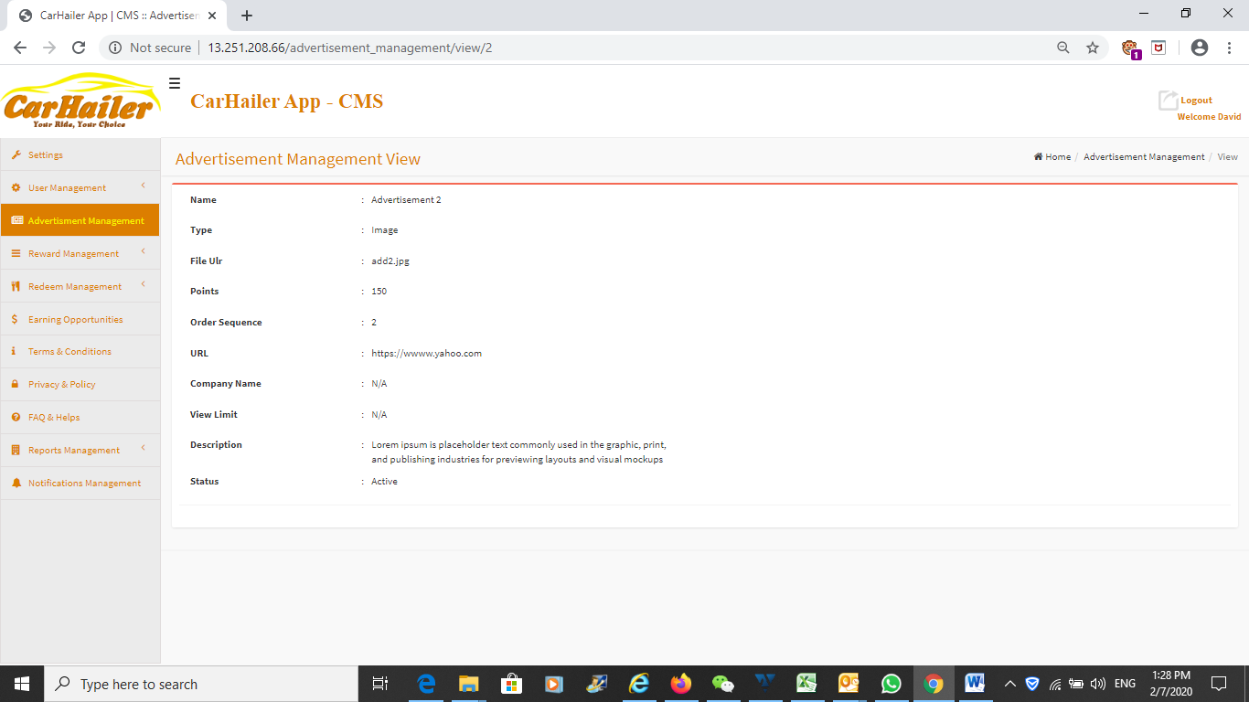

View the advertisement setting.

This page is not fully developed.

This page should display the banner picture, blast picture and also the video picture of the advertisement.

* 1. **Advertisement Management page - Adding**

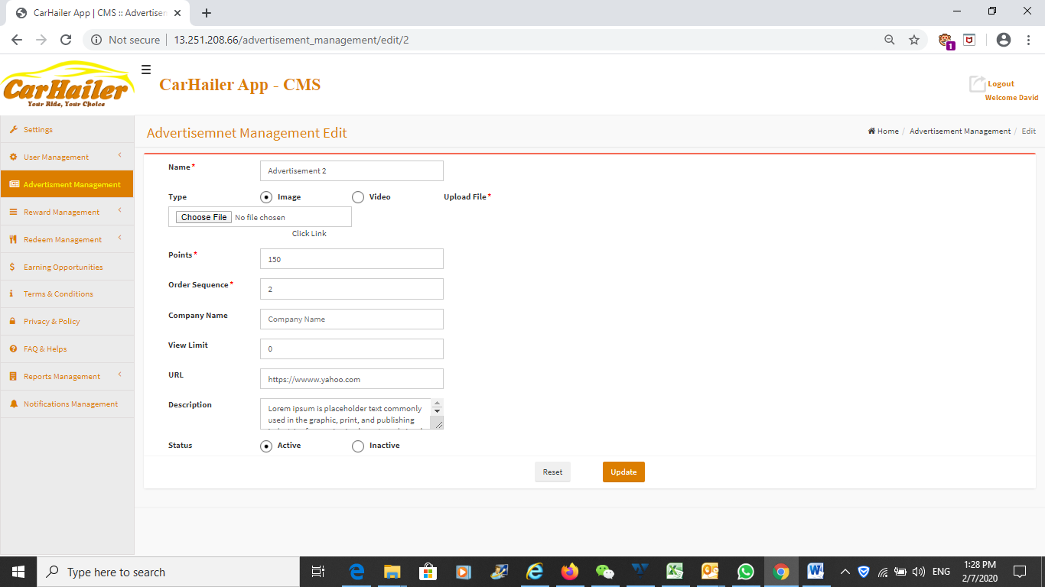

This is to add in the Banner Advertisement.

The insertion is unfriendly. There should be a window that size correctly to the banner size. The admin will just need to fit the video, poster or any pictures into the window size and it will be displayed correctly on the frontend app.

Should have a preview function to see the display when posted that will appear on the frontend mobile app.

The User Interface is unfriendly. There should be an edit or create function with the phone face in place and Admin is able to drag the picture into the relevant boxes.

The display for the description.

Setting the number of view limits.

The video, banner, poster advertisement must show to the user the number of clicks or view that he have accessed to this advertisement.

Need to plan out how to insert in a survey posting section into this page.

Need to show the number views of clicks that have already achieved on the various advertisements.

Need to build AI into this section so as to provide analytical data to advertisers.

* 1. **Advertisement Management page – Adding an Advertisement**

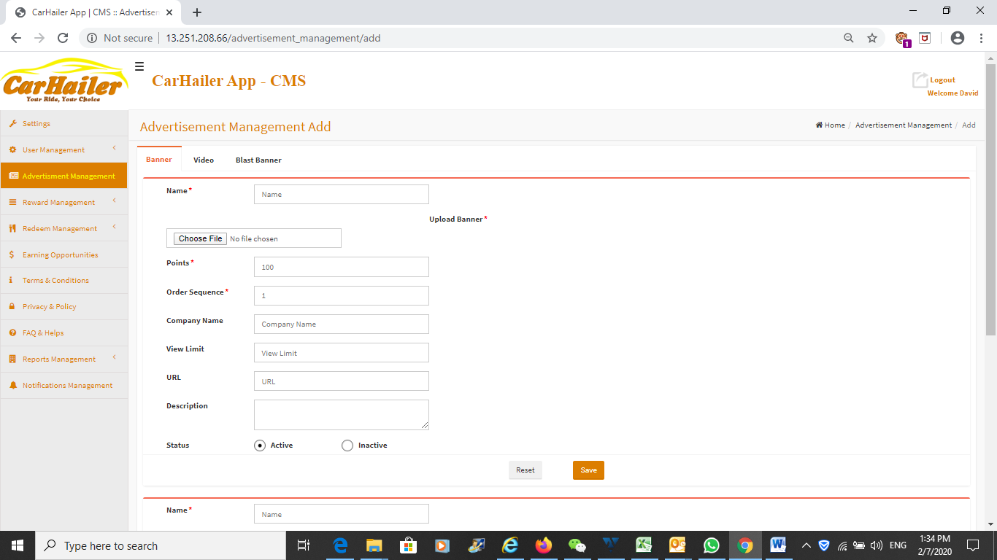

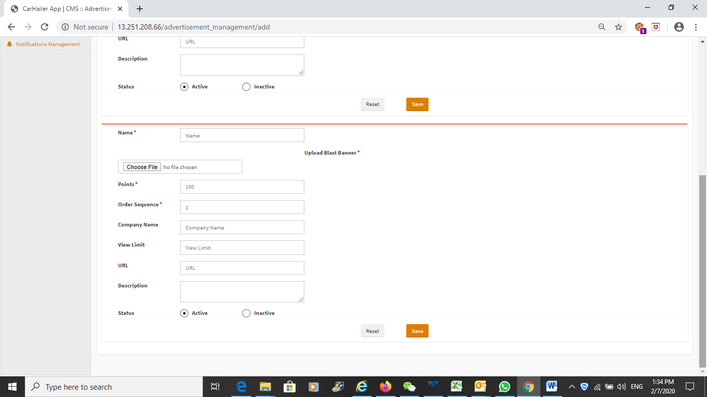

This is to add in the Banner Advertisement.

The insertion is unfriendly. There should be a window that size correctly to the banner size. The admin will just need to fit the video, poster or any pictures into the window size and it will be displayed correctly on the frontend app.

Should have a preview function to see the display when posted.

The display for the description.

Setting the number of view limits.

The video, banner, poster advertisement must show to the user the number of clicks or view that he have accessed to this advertisement.

Need to plan out how to insert in a survey posting section into this page.

* 1. **Advertisement Management page – Video Management**

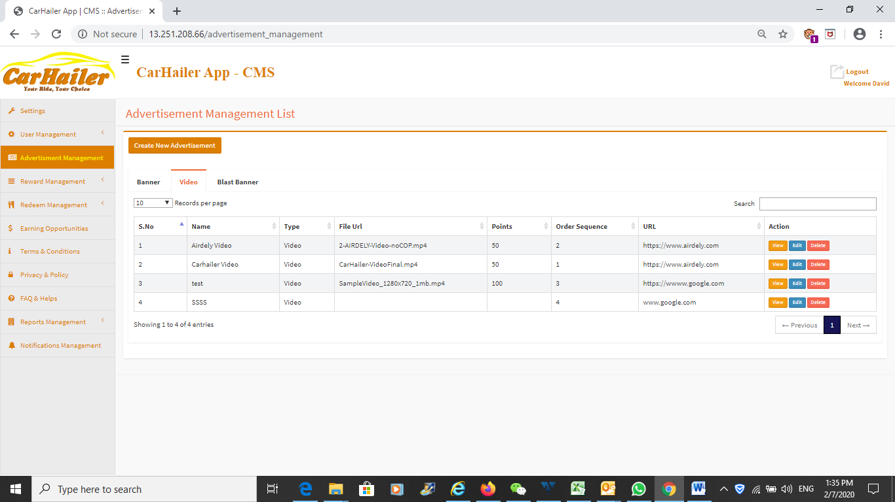

This page able to see the number of video advertisements that are currently running.

Can edit, add, delete and view the advertisements from here.

* 1. **Advertisement Management page – Video Management**

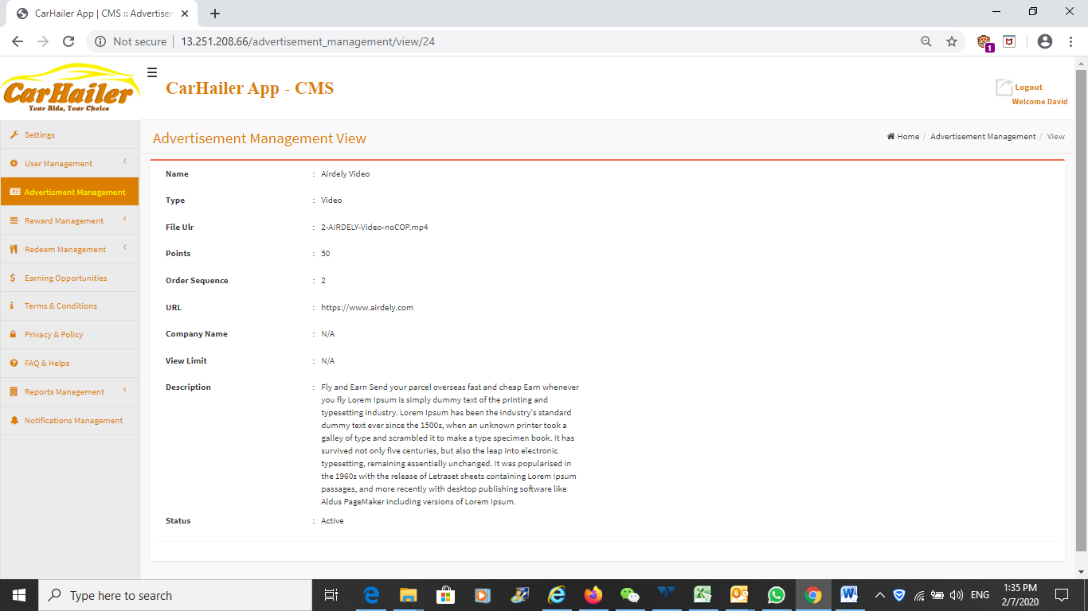

Viewing the advertisement in the backend. Should display the pictures and also the frontend UI for better clarity and understanding of the advertisement.

Need to see how the advertisement display on the frontend mobile app.

The insertion is unfriendly. There should be a window/phone face that size correctly to the banner/video size. The admin will just need to fit the video, poster or any pictures into the window size and it will be displayed correctly on the frontend app.

Should have a preview function to see the display when posted.

The display for the description.

Setting the number of view limits.

The video, banner, poster advertisement must show to the user the number of clicks or view that he have accessed to this advertisement.

Need to show the number views of clicks that have already achieved on the various advertisements.

Need to build AI into this section so as to provide analytical data to advertisers.

* 1. **Advertisement Management page – Add Video Management**

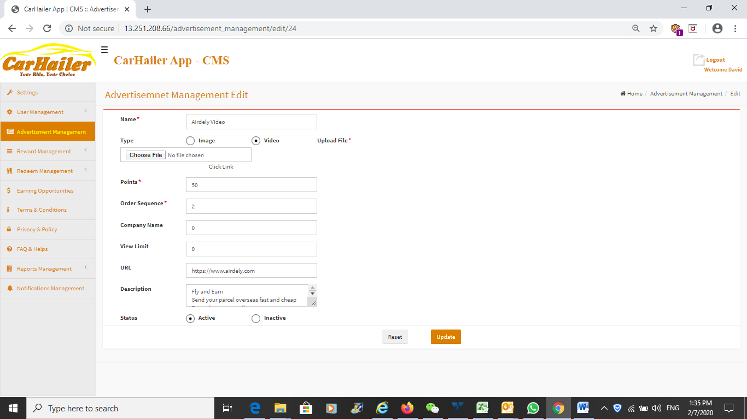

Adding the video advertisement.

Comments as previous pages.

More importantly, must have a friendly interface over here. The creation of the video advertisement must be done from here. There must be a preview function. Need to have the phone face over here so that what you do over here is what you will get to display on the frontend mobile app.

* 1. **Advertisement Management page – Blast Advertisement Management page**

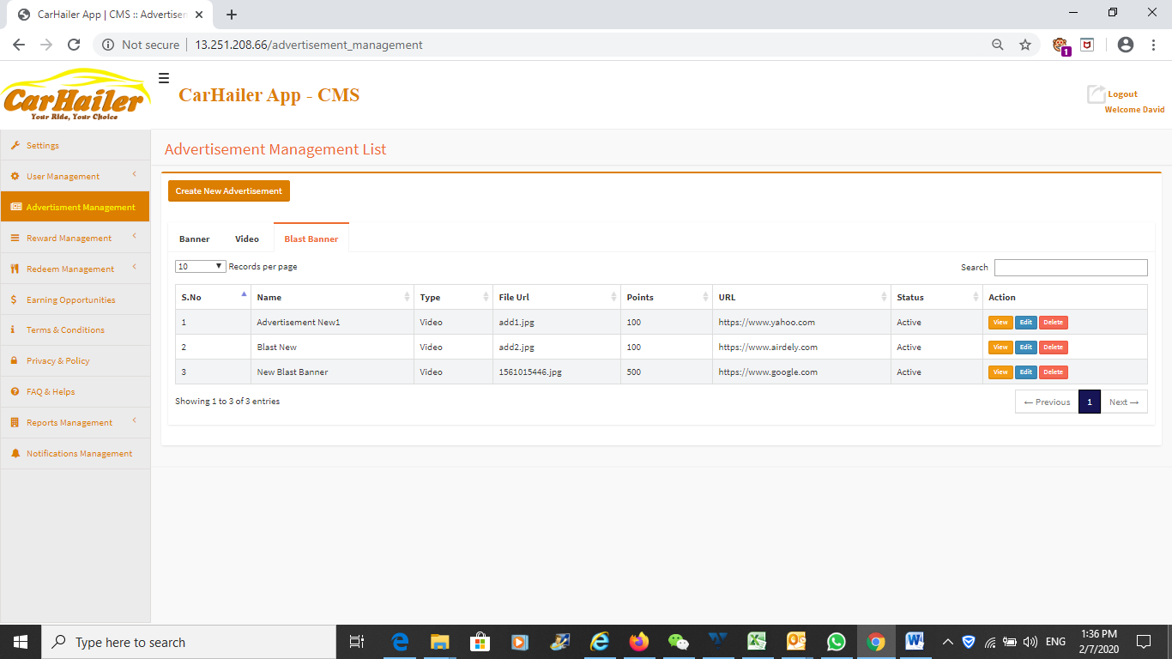

Blast Advertisement.

The blast advertisement is a pop up poster whenever the user opens the frontend mobile app.

There are many blast advertisement that can be added.

The blast advertisements will be shown one at a time but changes every time the same user opens the app.

Blast advertisement will also earn points for the user when clicked. When the click limits of a particular user is reached, there will be a popup window telling him that he has reached his click limits. Same goes for the rest of the banner advertisement and video advertisements too.

Same as previous comments, the creation of the Blast advertisement must have an interface over here. So that the Admin creating the advertisement exactly knows how it will appear on the frontend mobile app.

Currently the Blast advertisement goes into a streaming mode when more than one Blast advertisements are added. This is not the case. As described above, it should only be one at a time.

* 1. **Advertisement Management page – View Advertisement setting**

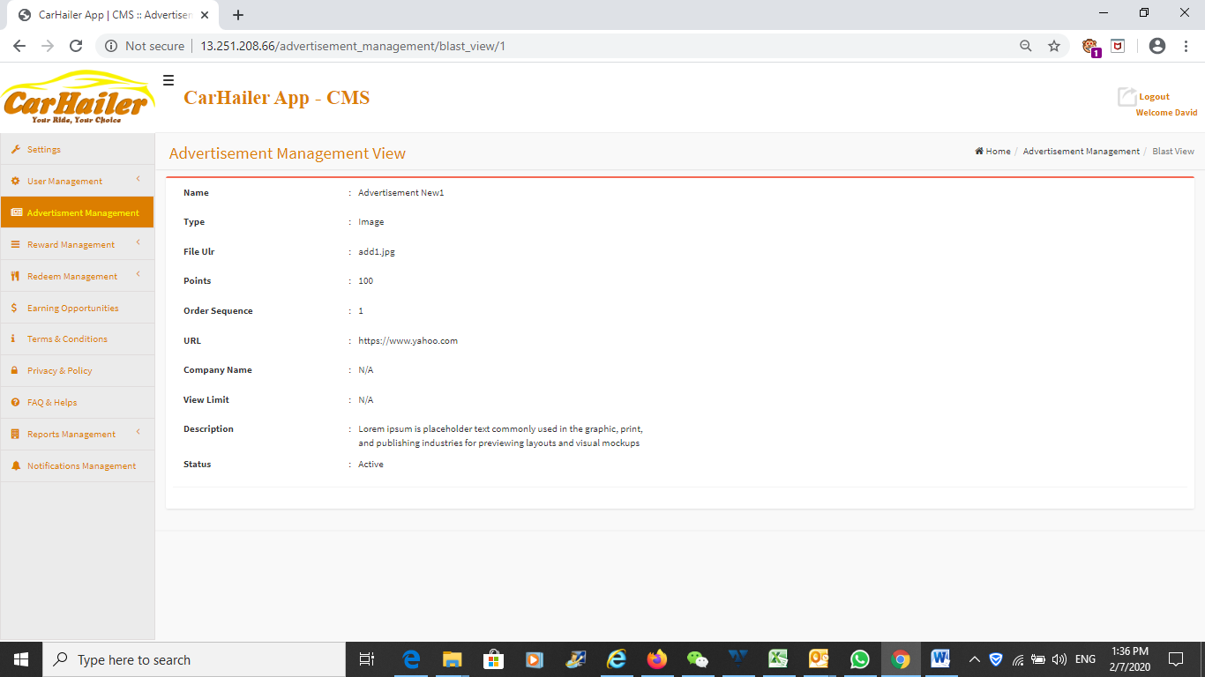

Viewing the advertisement setting.

The appearance of the advertisement must be shown here and not just wordings. The display on the frontend mobile app must be shown.

* 1. **Advertisement Management page – Add Blast Advertisement**

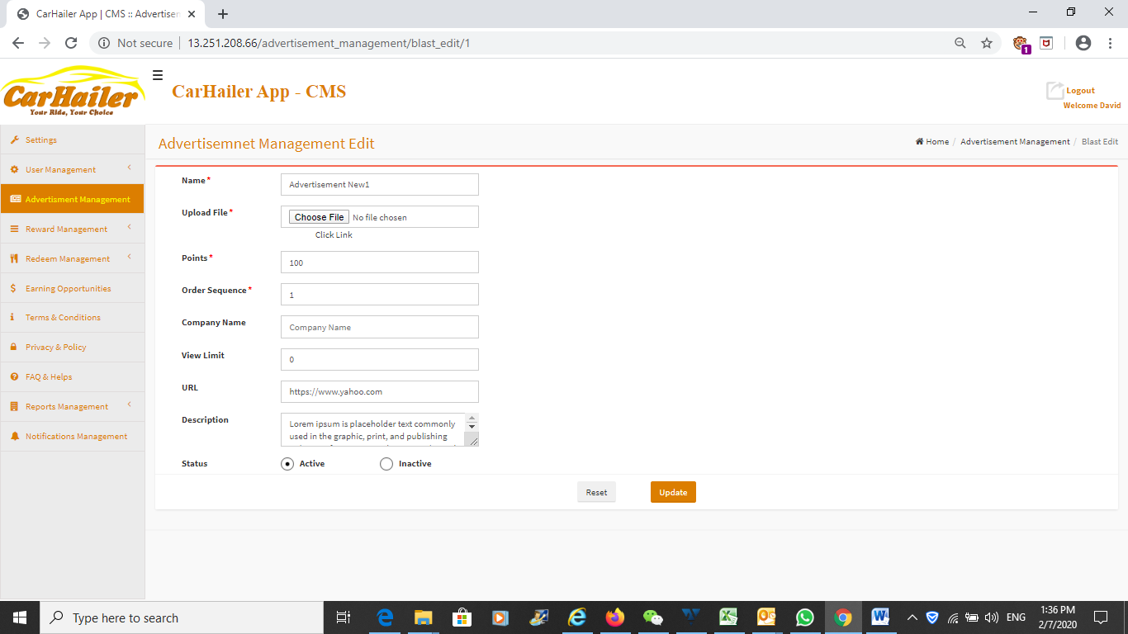

As mentioned, the Admin user interface over here needs to be enhanced.

Need the display of the phone that the advertisement will be presented on the frontend mobile app.

The Blast advertisements can also be set to Active or Inactive from here.

* 1. **User Reward Points management page**

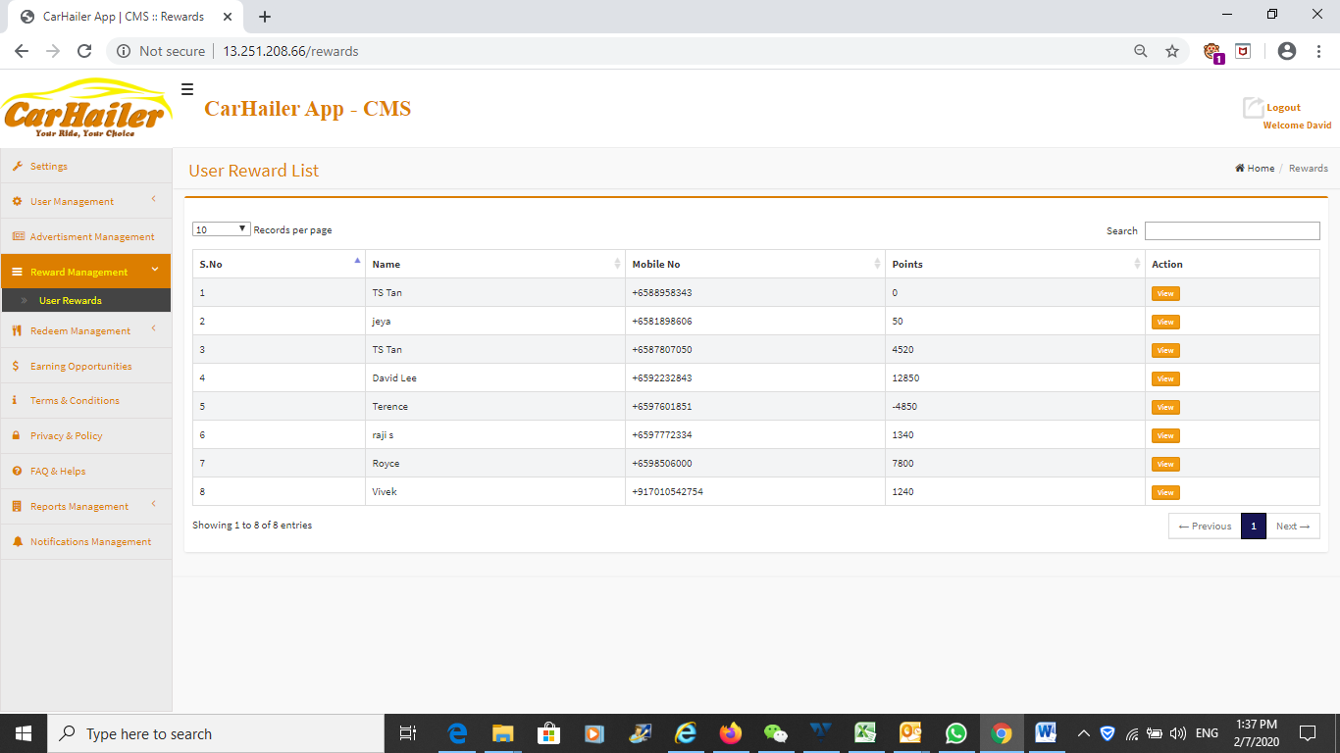

This page shows the User reward points.

Should have a summary of points earned, points redeemed, points balance.

When view, there is a user reward history, will show the list of redemption that he had done and date and time of the redemption and the item description.

The points of the user can be edited from here if there is any dispute or calculation error. This can be done by the Admin.

The function should be made available here. Currently it is under the User Management page.

* 1. **Redemption page**

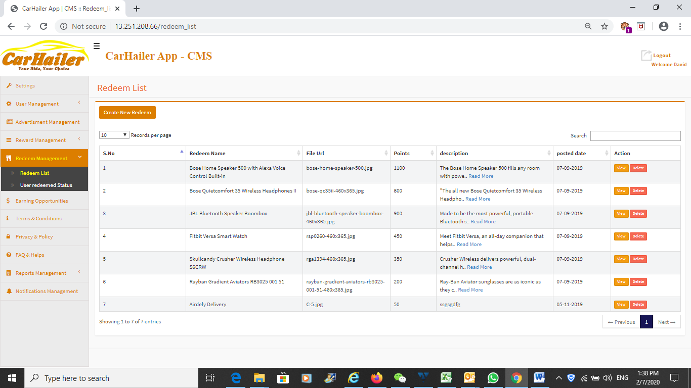

This is the Redemption management page.

This page give an overview on all the items that are available for redemption.

Need to have a Stock Keeping Unit over here to control the number of stock available and being redeem. Currently, this is manually handled.

The Admin will need to check on this page and see what are the items being redeemed by the User. Individual redemption is handled manually currently.

* 1. **Redemption page – Posting Redemption Item – View page**

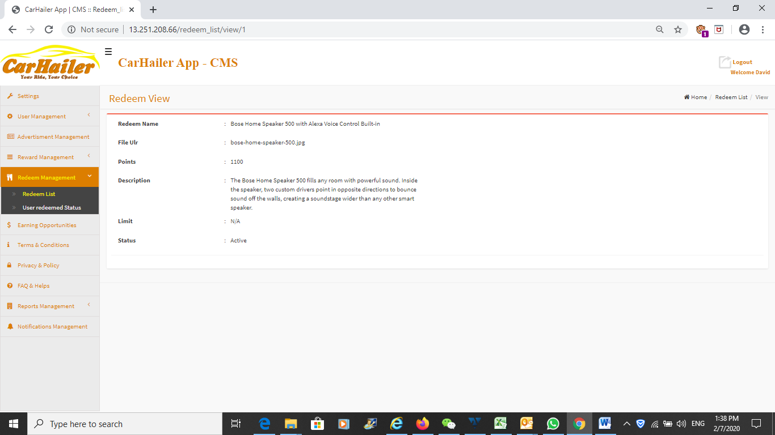

Same comments as the advertisement.

This page should be more user friendly. There should be a display on the frontend app how will the posting be like. The page should display the frontend UI so that the Admin is able to plan and layout the various redemption just like an ecommerce site.

The redemption item picture should be seen from this page too.

* 1. **Redemption page – Posting Redemption Item – Adding page**

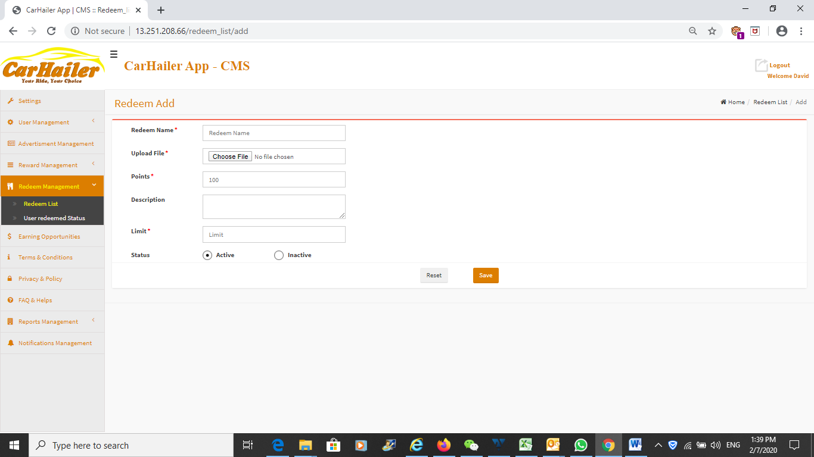

See previous page comments.

Frontend UI must be displayed for better appreciation.

This page should be more user friendly. There should be a display on the frontend app how will the posting be like. The page should display the frontend UI so that the Admin is able to plan and layout the various redemption just like an ecommerce site.

The redemption item picture should be seen from this page too.

* 1. **Redemption page – User Redemption Status**

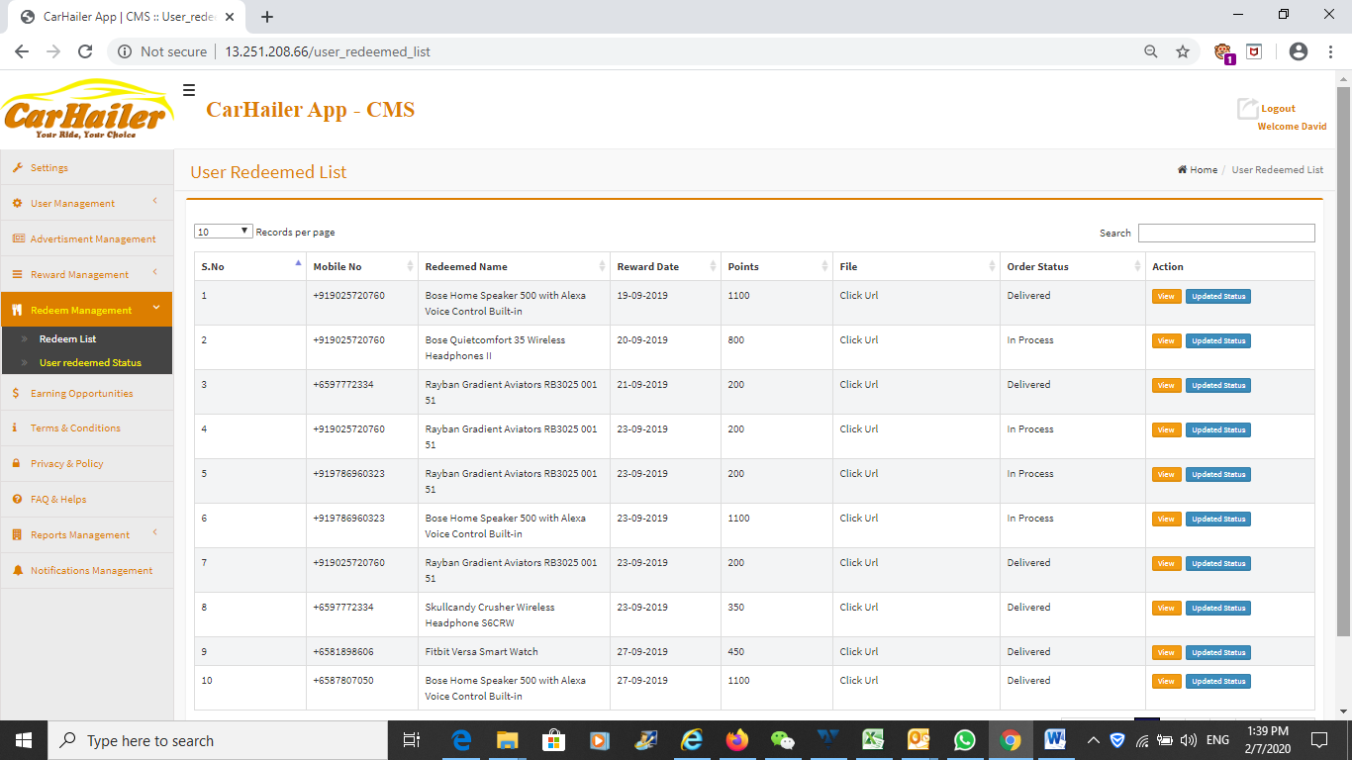

This is the user redemption status.

Action button to show if it is redeemed or under processing.

As mentioned, there must be Stock Keeping Unit over here to take stock on the item being redeemed.

If the stock low, must be able to alert the Admin.

In addition, the number of stock left must also be displayed on the Frontend app. If the stock is running to ZERO, then the User will not be able to redeem this item any more from the mobile app.

* 1. **Redemption page – User Redemption Status**

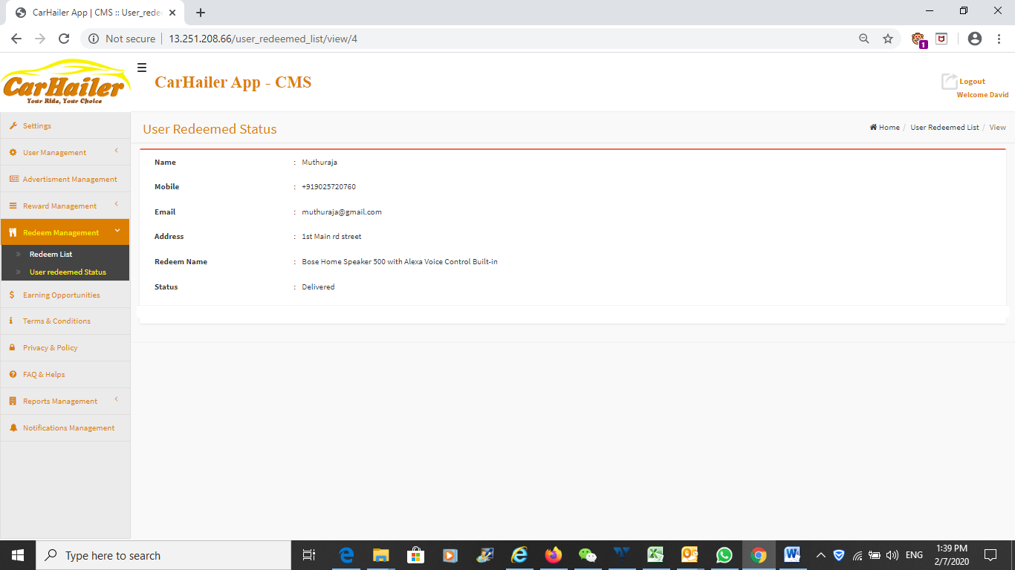

Checking the redemption status of the user.

* 1. **Redemption page – User Redemption Status - Updating**

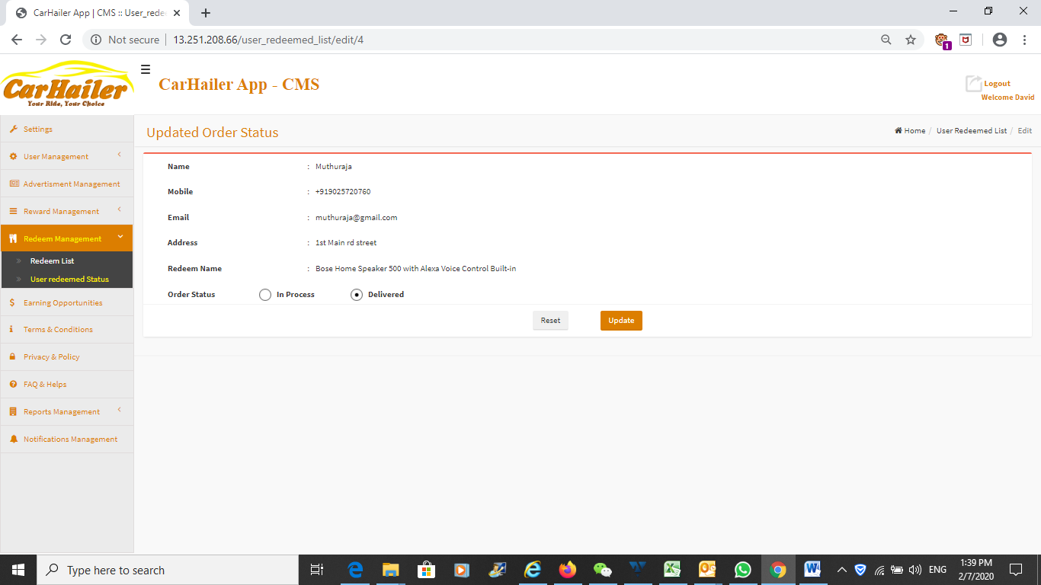

This page is to check off if the item has been delivered to the User.

Currently all these are done manually. However, will need to incorporate a function automatically delivered if it is a e-voucher or digital voucher.

* 1. **Earning Opportunities Control page**

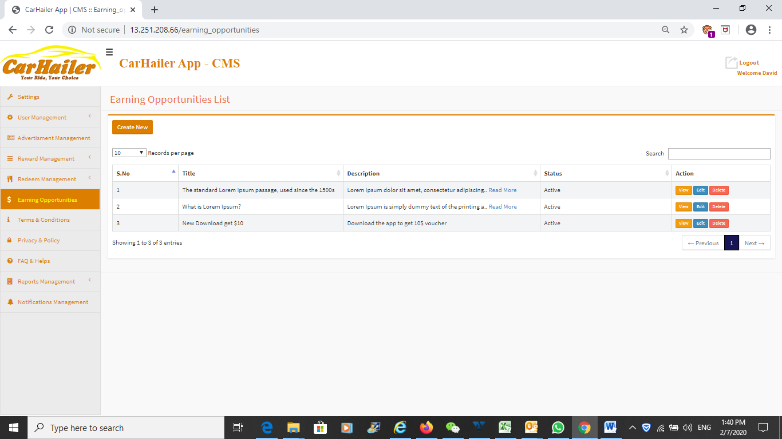

This is a description given as to how to use the app for reward points earning and also how to earn points using the app.

What you input over here is what it will be updated on the frontend mobile app.

Very similar to the FAQ portion.

* 1. **Earning Opportunities Control page – Editing page**

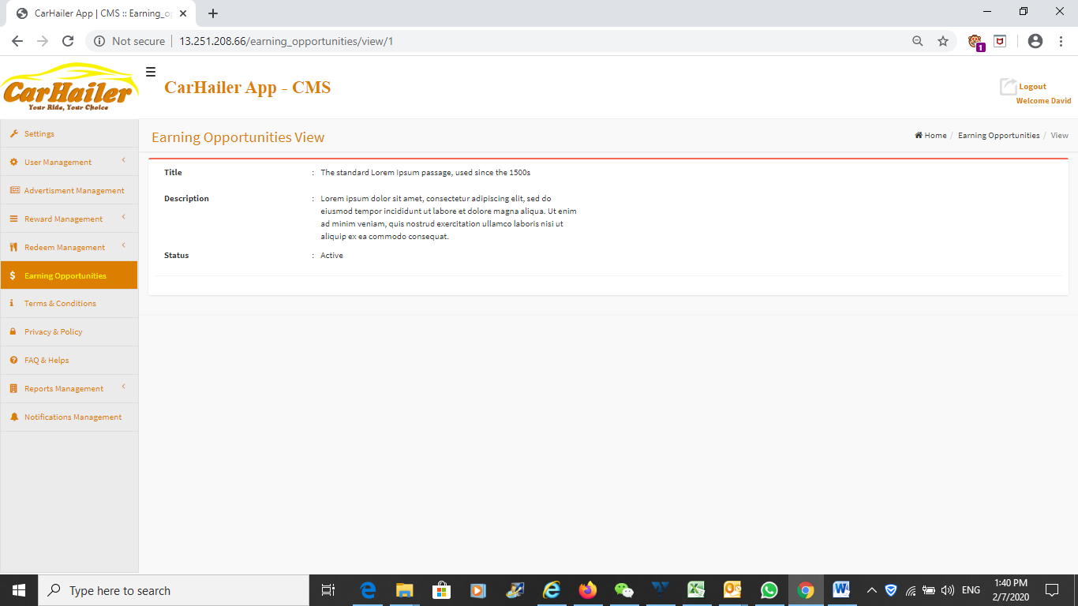

This is to add items to the Earning Opportunities page in the Frontend app.

Viewing what is being shown on the frontend.

Lack of friendly UI. The small little input box is no good for insertion and lack proper word processing ability. Hence will be good to insert a Word Processor here to replace the small little input box.

Example as follows:

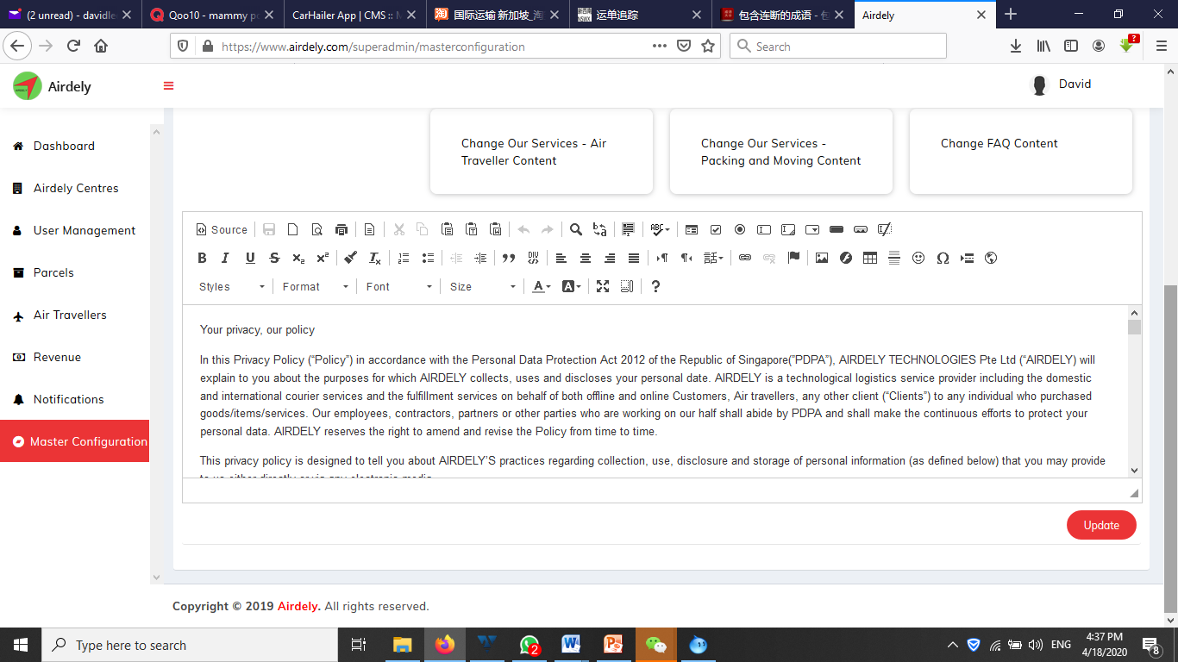

* 1. **Earning Opportunities Control page – Editing page**

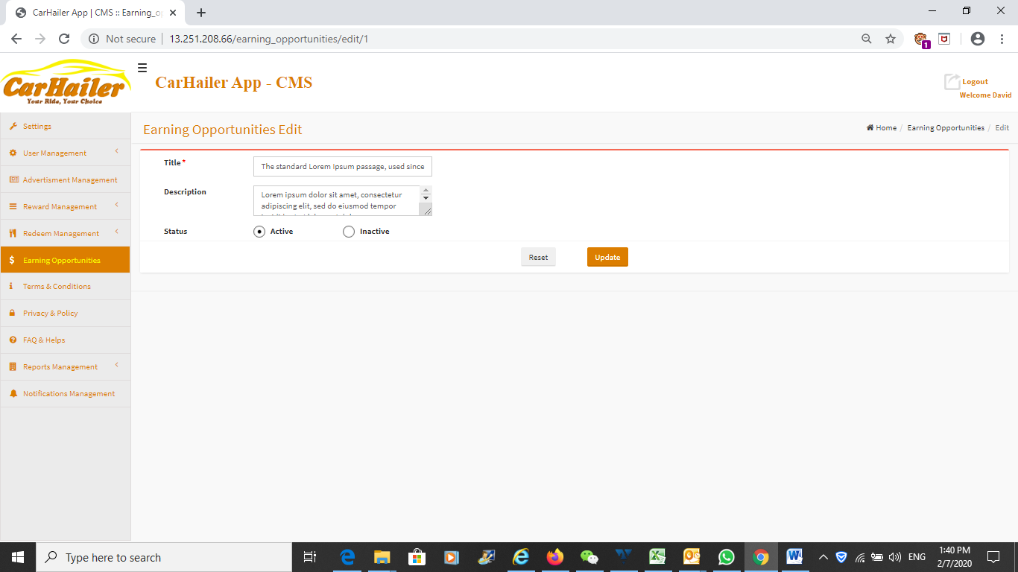

As mentioned in the previous page, will need to insert a proper word processor into here for proper management of the text to be displayed on the frontend app.

* 1. **Earning Opportunities Control page – Adding New Messages**

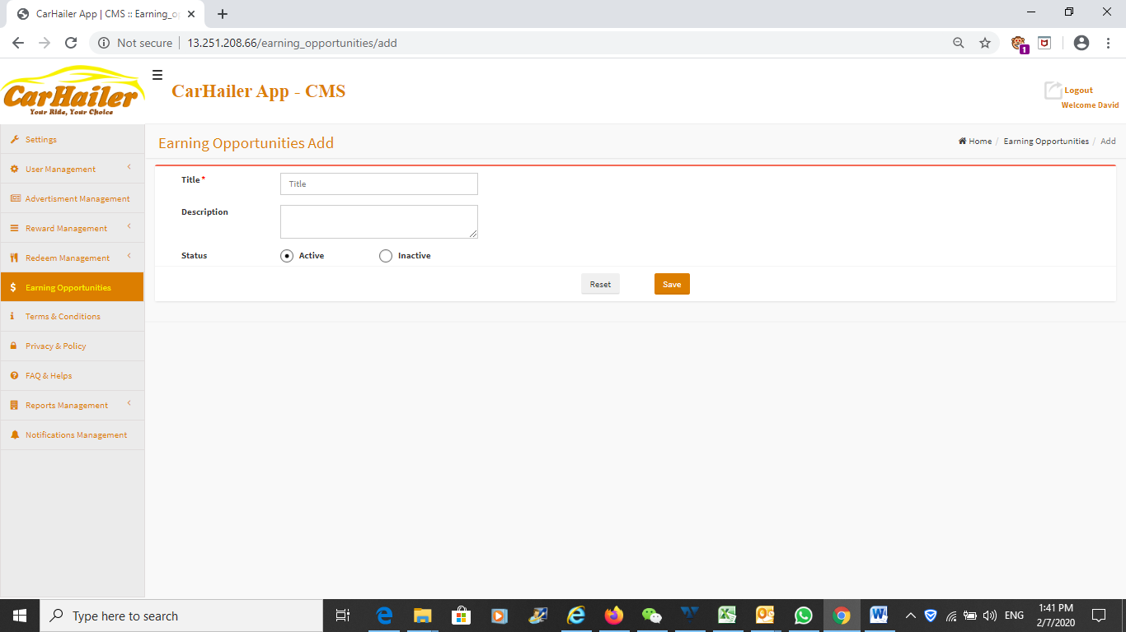

Comments as previous page.

* 1. **Terms and Conditions Control page – View page**

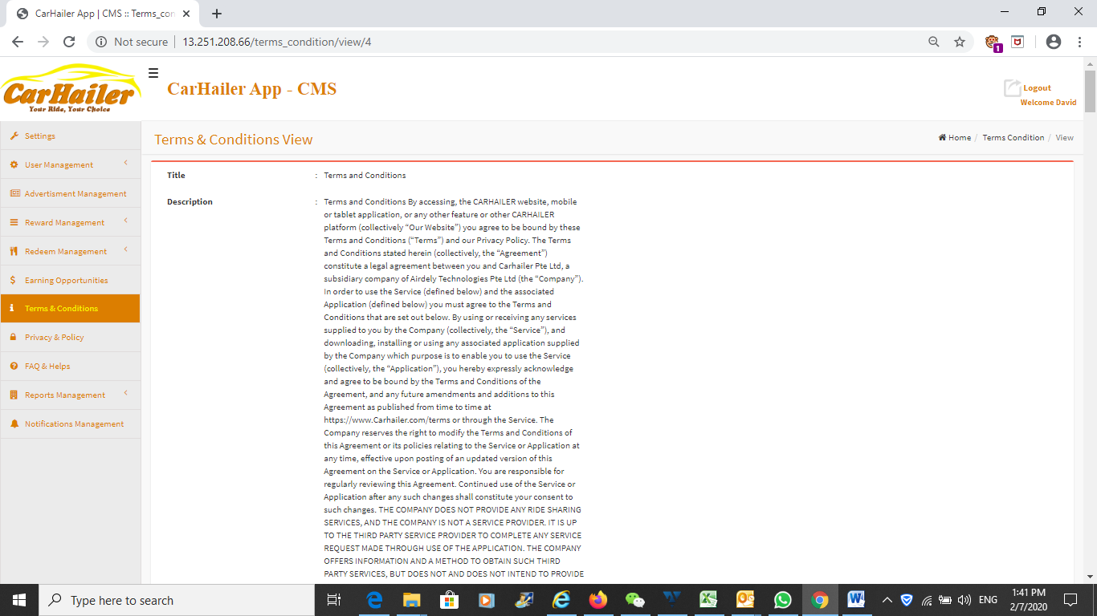

Viewing the T & C.

This should be a Word Processor and not a simple window to type in the contents.

* 1. **Terms and Conditions Control page – Edit page**

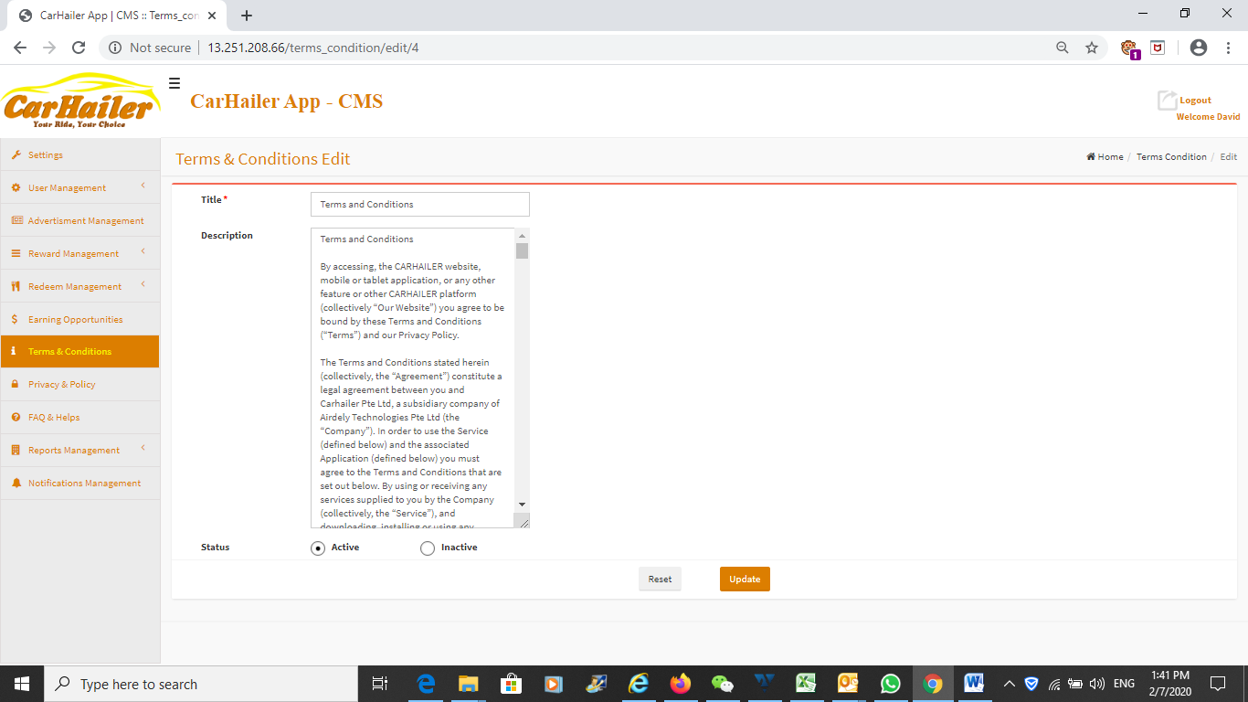

Editing the T & C.

Once updated, the frontend app will also be updated too.

As before, the input box should be replaced with a proper Word Processor as described previously.

What you type into the Word Processor and update will be the same as what it will be displayed on the frontend mobile app.

* 1. **Privacy Policy Control page – View page**

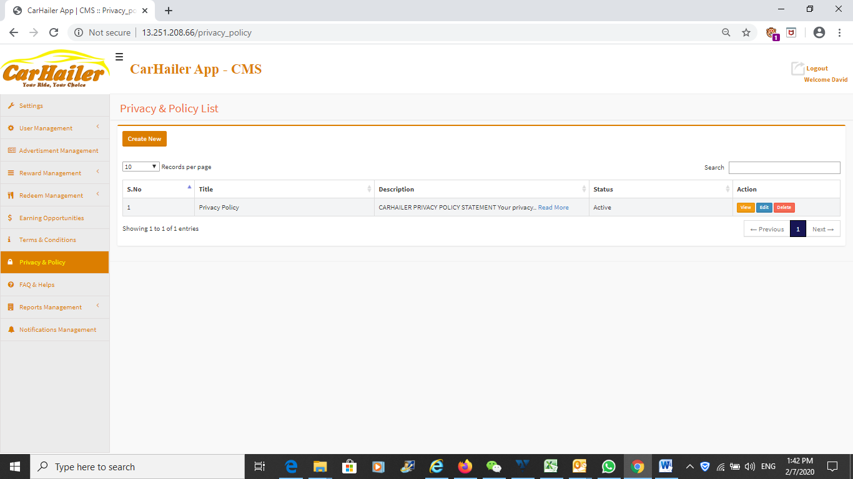

Privacy Policy Statement management page.

* 1. **Privacy Policy Control page – View page**

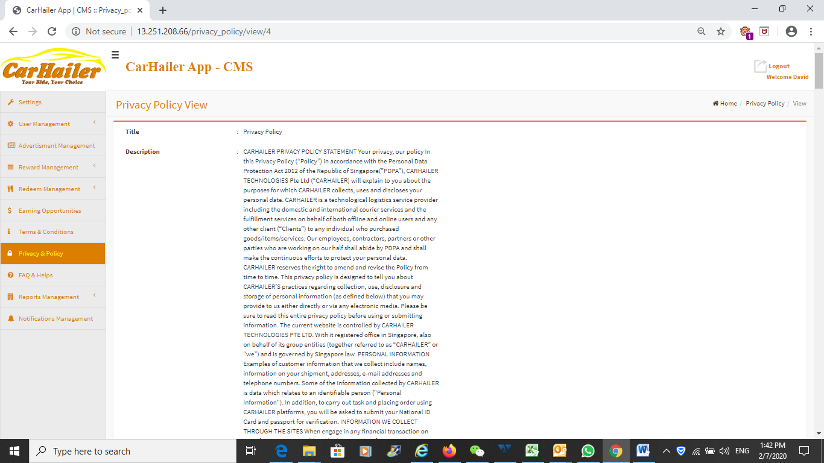

Viewing the Privacy Policy Statement.

This should be a Word Processor and not a simple window to type in the contents.

* 1. **Privacy Policy Control page – Edit page**

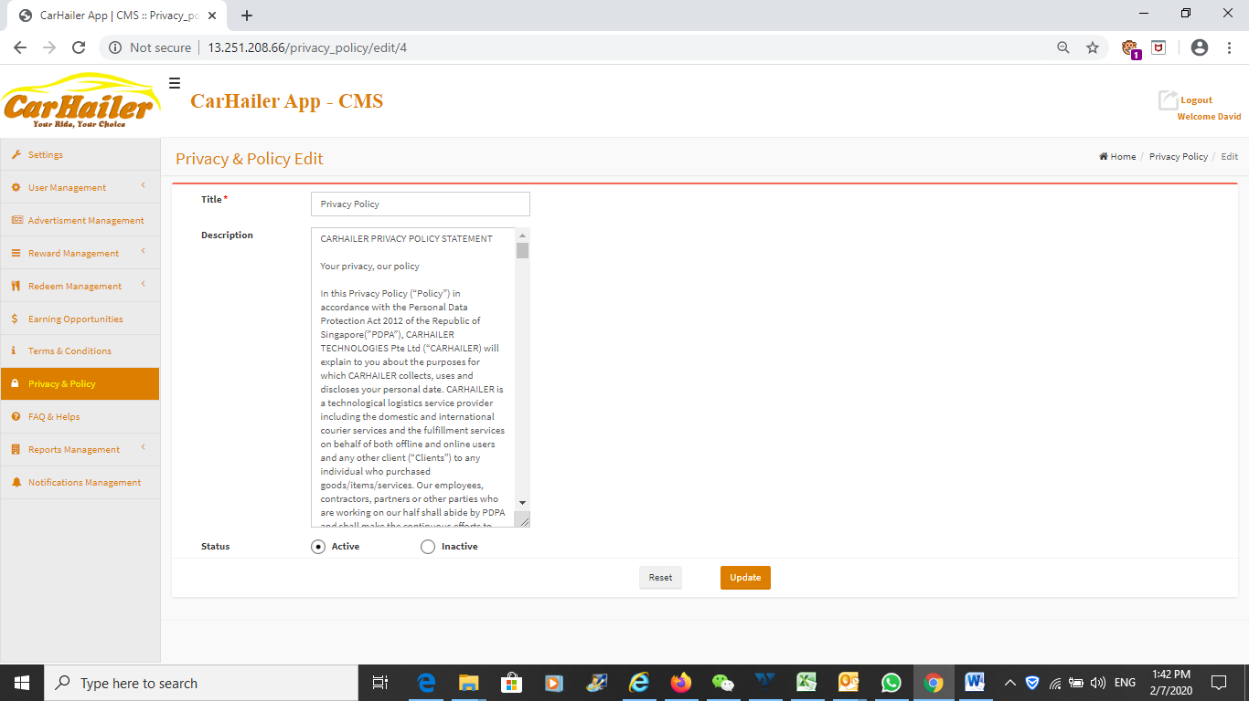

Editing/Adding the Privacy Policy Statement.

Once updated, the frontend app will also be updated too.

As before, the input box should be replaced with a proper Word Processor as described previously.

What you type into the Word Processor and update will be the same as what it will be displayed on the frontend mobile app.

* 1. **FAQ Management – Overall View page**

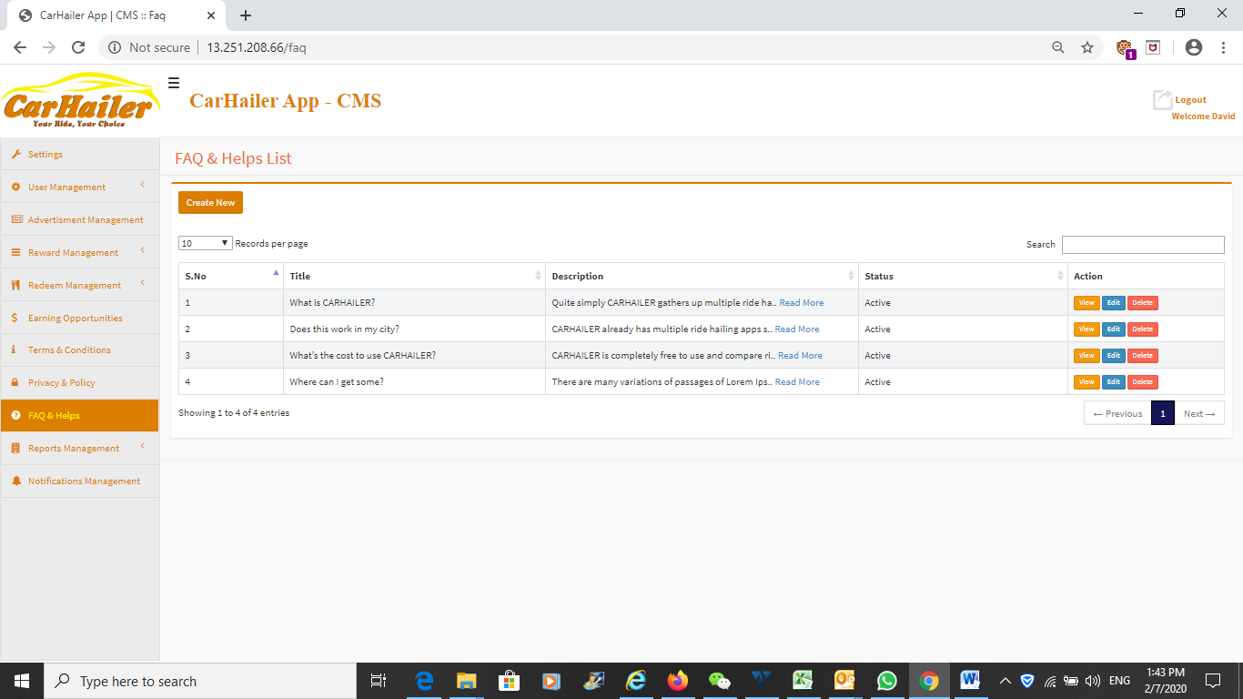

FAQ Management page.

* 1. **FAQ Management – Overall View page**

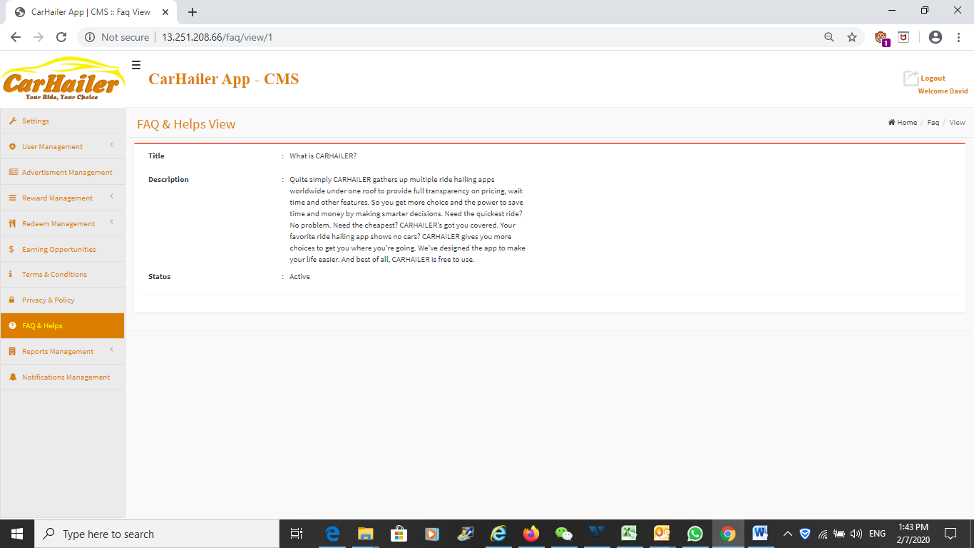

Adding and editing the FAQ.

Same as previous, will need a proper Word Processor and not a simple box to type in the contents.

* 1. **FAQ Management – Add or Edit FAQ**

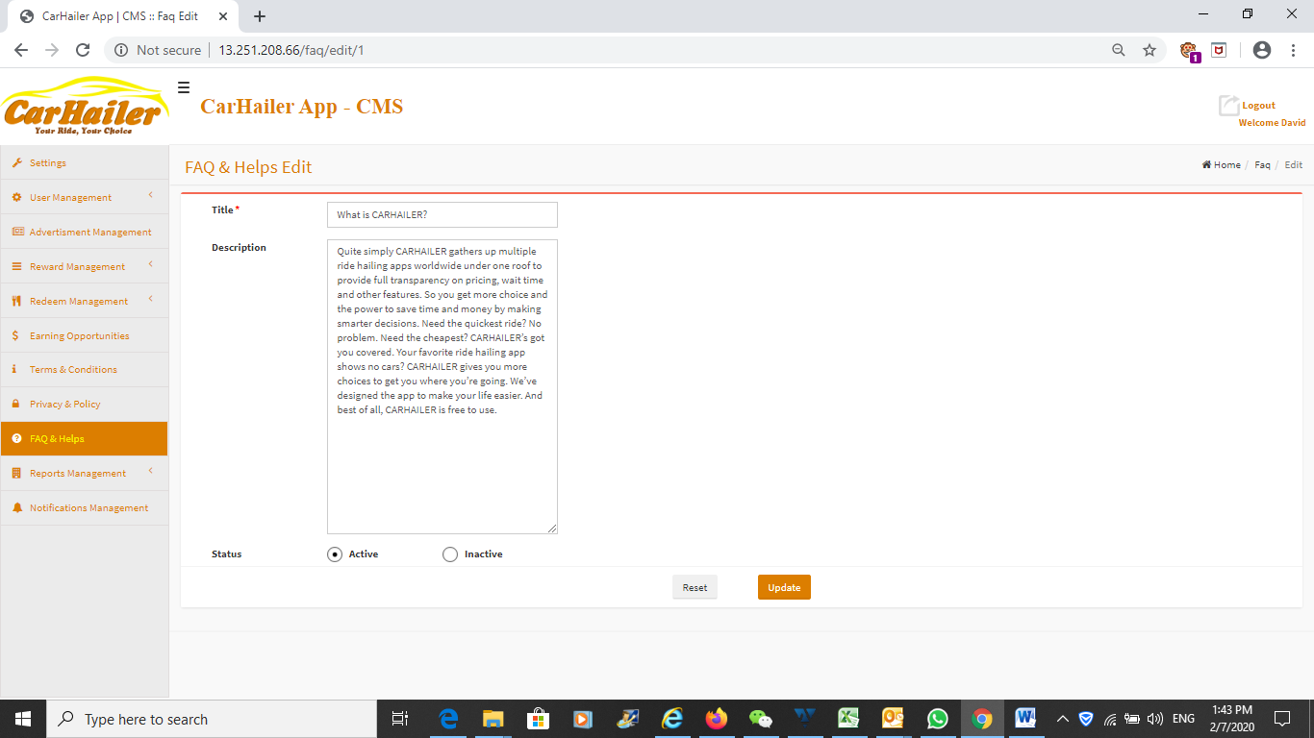

Adding and editing the FAQ.

Once updated, the frontend app will also be updated too.

As before, the input box should be replaced with a proper Word Processor as described previously.

What you type into the Word Processor and update will be the same as what it will be displayed on the frontend mobile app.

Preferably all the above text content management should consolidate into one side menu and not separate them, taking too much space on the side menu. Please see below example:

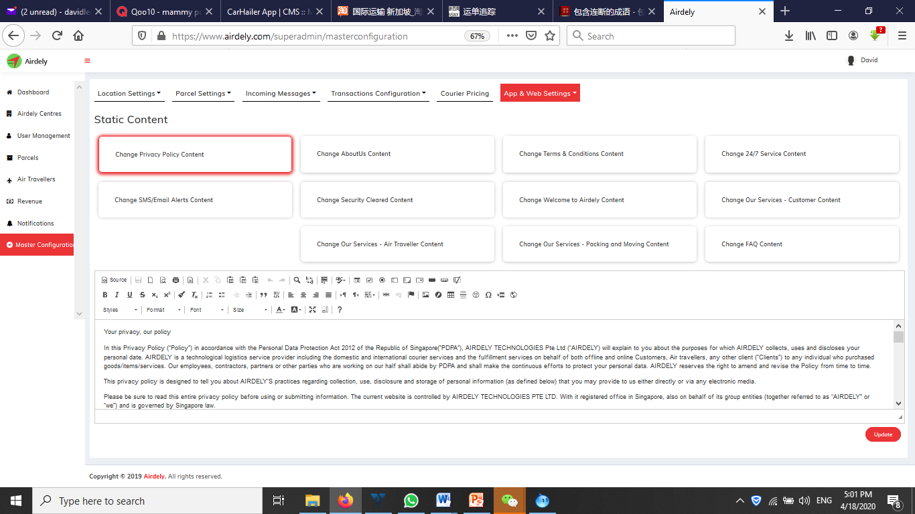

* 1. **Content Management Page**

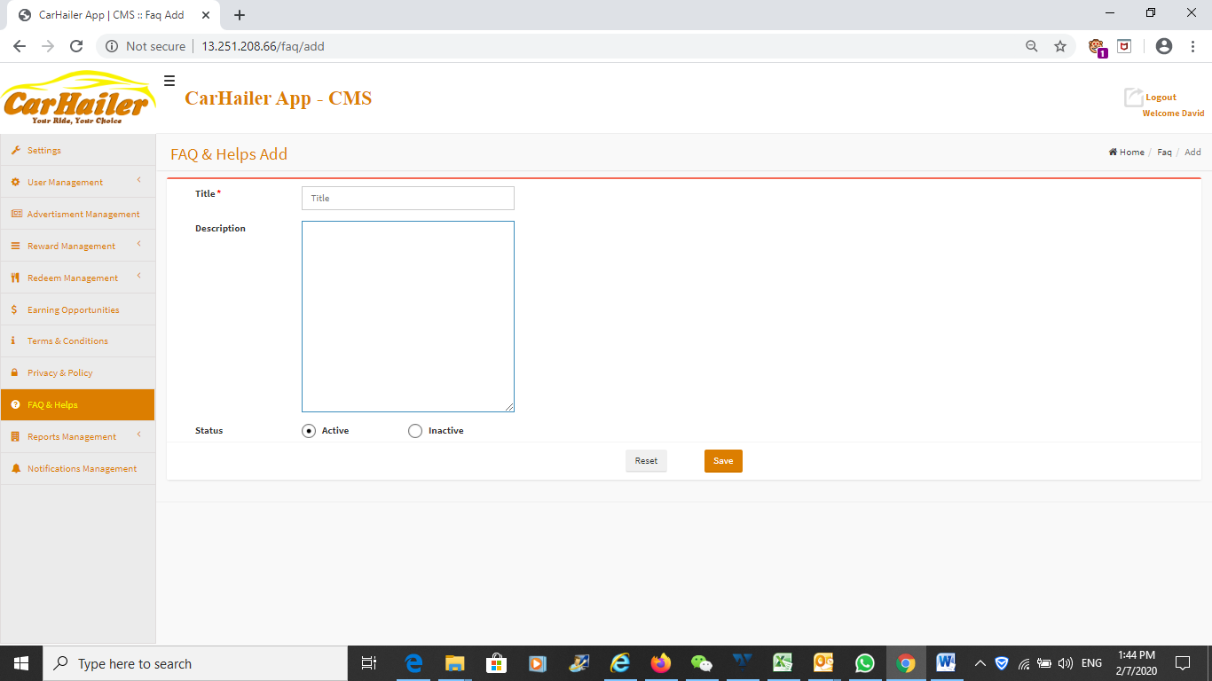

This page is yet to be fully developed.

This page will control the various layouts of the frontend mobile app and also the website when developed.

The icons and pictures being used in the frontend mobile app can be edited, changed from this page.

Again will need a proper Word Processor for better text control.

* 1. **User Ride History page**

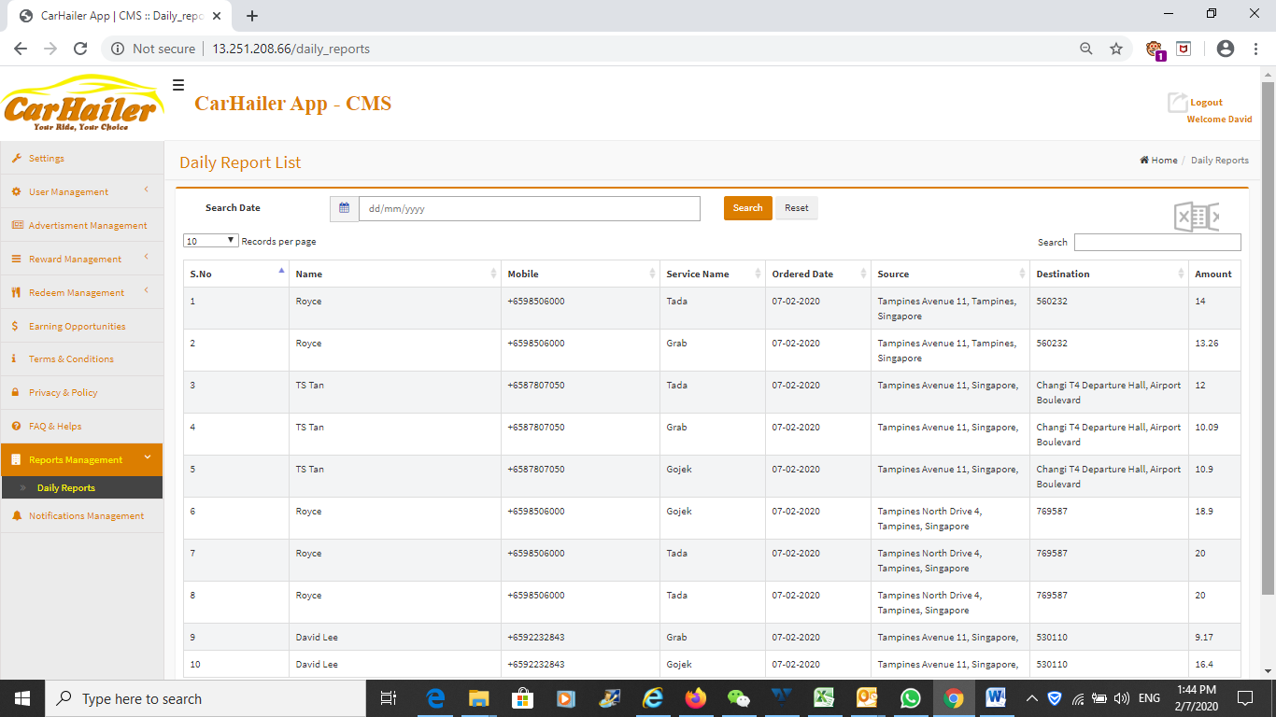

This page show all the rides booking history of all users.

There should be AI build into this to analyse the various ridesharing companies and also the travel habits of the users.

* 1. **Notification Management page**

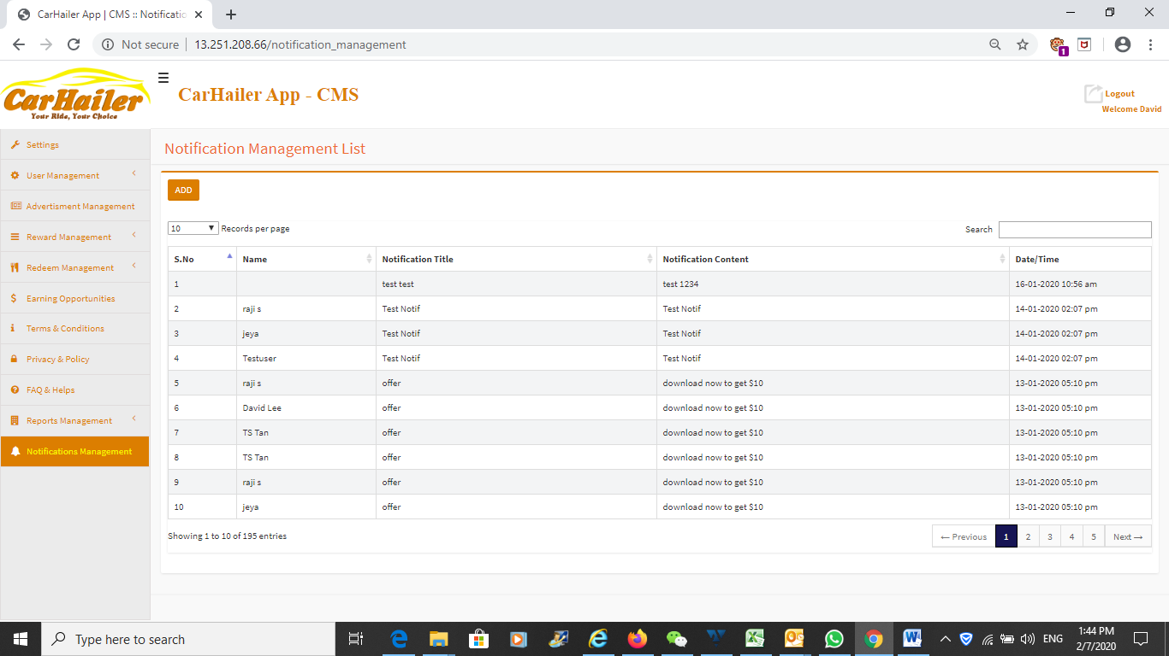

Notification management page.

This is the overview on the number of notification being sent out.

Will need to have a delete function over here when the notification is no longer relevant or obsolete.

* 1. **Notification Management page – Sending Notification**

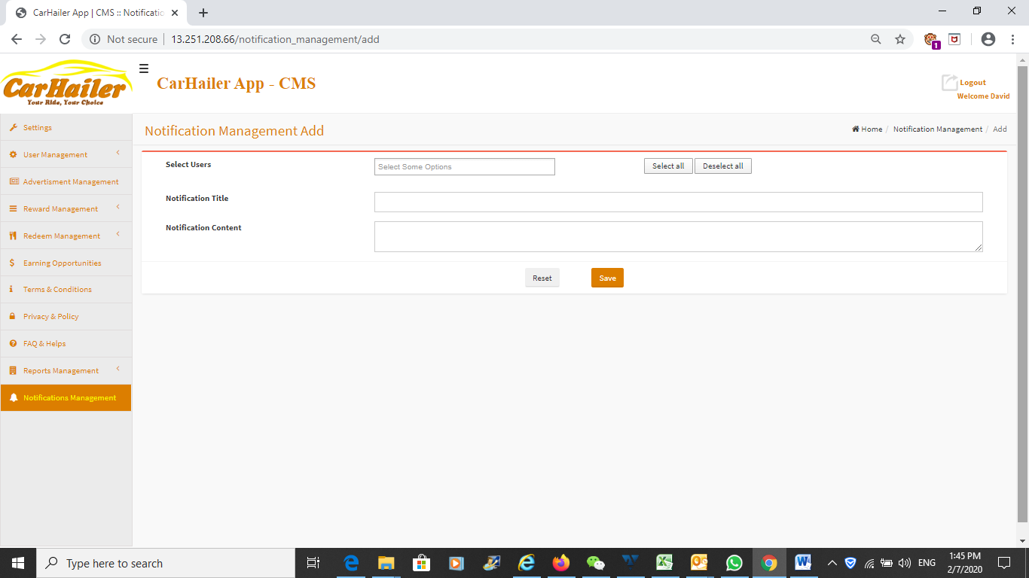

Adding and sending notification.

There should be no limit on the number characters being sent.

Can select sending push notification only, email only or notification and email at the same time.

Can select to individual user, selected users or blast to all users.

**That’s all for the Backend Admin Control web.**